

We are safe inside and out,

inside and out,

inside and out,

We are safe inside and out,

Walk, Watch, Safety!

We are kind to everyone,

everyone,

everyone,

We are kind to everyone,

Speak and Play Friendly!

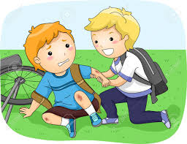

We’re respectful every day,

every day,

every day,

We’re respectful every day,

Thanks, Please, Helpful!

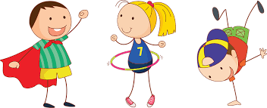

We’re responsible, hooray!

(clap) hooray!

(clap) hooray!

We’re responsible, hooray!

Capable and Powerful!

_____________________________________________________________________________________