 | Name: Date:
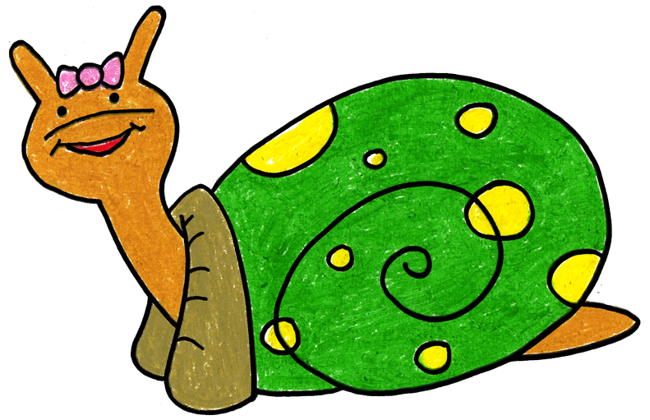 | Name: Date:
 | Name: Date:
 | Name: Date:
Please use the PDA strips below to write your PDA or PDA plus. A PDA a day can make a child’s day. You can put the PDA strip in the child’s cubby or in the mailbox at the end of the day. What PDA or PDA plus will you write today?

Name: Date:

Name: Date:

Name: Date:

Name: Date:

