The Leadership Team’s Guide for
Re-Opening Programs
By Anna Winneker, Lise Fox,
Meghan von der Embse,
Erin Sizemore, and Dana Peña
Adapted for California by
CA Collaborative on the Social
Emotional Foundations for
Early Learning (CA CSEFEL)
Contents
Introduction 1
Creating Your Re-Opening Plan 1
Considerations for Supporting Program and School Staff 2
Reconnecting with Families and Children 4
Considerations for Supporting Relationships with Families 4
Considerations for Supporting Relationships with Children 5
Classroom Environments 6
Considerations for Classroom Environments 7
Promoting Social Emotional Skills and Responding to Challenging Behavior 9
Considerations for Teaching Social Emotional Skills, Preventing Challenging Behavior, and Responding to Children When Challenging Behavior Occurs 9
Embedded Hyperlinks 11



National Center for Pyramid Model Innovations | ChallengingBehavior.org
The reproduction of this document is encouraged. Permission to copy is not required. If modified or used in another format, please cite original source. This is a product of the National Center for Pyramid Model Innovations and was made possible by Cooperative Agreement #H326B170003 which is funded by the U.S. Department of Education, Office of Special Education Programs. However, those contents do not necessarily represent the policy of the Department of Education, and you should not assume endorsement by the Federal Government.
Pub: 07/13/2020 Adapted for use in California by the California Collaborative on the Social Emotional Foundations for Early Learning (CA CSEFEL) 07/27/20

The Leadership Team’s Guide for Re-Opening Programs
Anna Winneker, Lise Fox, Meghan von der Embse, Erin Sizemore, and Dana Peña
Adapted for use in California by the California Collaborative on the Social Emotional Foundations for Early Learning (CA CSEFEL) 07/27/20

Introduction
The pandemic has created challenges for children, families, and communities across the globe. Many families have experienced a host of hardships, including the serious illness of a family member, loss of loved ones, unemployment, and social isolation. In addition, many people have reported increased anxiety, difficulty coping, and concerns about their health and safety. All of this might have a deep impact on the children and staff in your program.

As programs and schools prepare to re-open following COVID-19 closures, it is essential to have a plan in place to welcome children’s return, support them and their families in learning new routines and procedures, and respond to children’s social emotional needs. In addition, the program should consider how to support staff and their feelings of wellness and safety.

This document is designed to guide the Program Leadership Team around considerations for supporting children, families, and staff as they return to the program. The guidance includes Teaching Pyramid practices you know and encourages you to think about those strategies from a trauma-informed perspective. While the leadership team may not know who among children, families, and staff have or are experiencing trauma, a trauma-informed approach guides programs in providing a safe and nurturing environment where children, families, and staff can build resilience, feel safe, and recover.

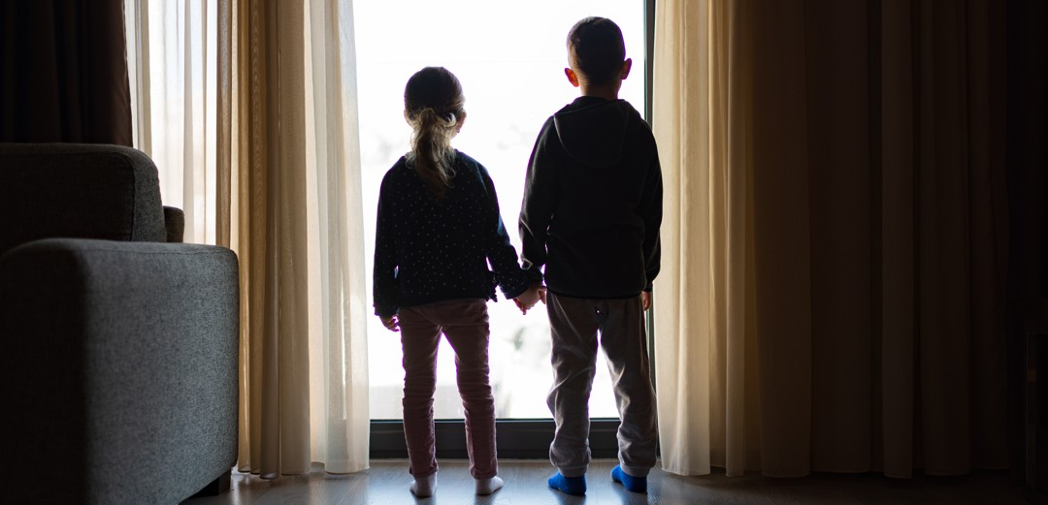
Creating Your Re-Opening Plan

Considerations for Supporting Program and School Staff
As you are preparing to return or are slowly getting back to capacity, establish a time to meet as a leadership team. Teams should consider how the pandemic has impacted not only the children in your program but family members and staff as well. In this document, we have provided considerations for the team to discuss and potential strategies that might be included in your re-opening plan.

Develop a plan for how teachers will be welcomed back to the program.
- In your welcome back to staff, prior to their return, let staff know that safety is a priority for the program and review the changes that have been made in procedures.
- When able, consider a welcome back meeting to celebrate being back to school. As part of the meeting, include time to discuss staff concerns and the strategies that have been put in place to address those concerns. Use this meeting to provide information about how the program will support staff, children, and their families.

Identify how new procedures will be communicated to families.
- Develop multiple ways to provide families with information about changes in procedures (e.g., drop-off and pick-up, wearing masks, toys or bedding from home). Consider sending emails, posting on your website or through social media, hosting a family virtual meeting to talk about the changes, and phone calls to families who might not access digital materials.
Communicating with Families: Helpful Suggestions1
- If you will be encouraging or requiring children and families to wear masks as part of your safety procedures, think about how you might make those available to families with limited resources.


Consider how you will provide a quality program to children who are attending in person and remotely or children who are only receiving services remotely.
- Carefully plan how you will provide services that support families in guiding their child’s learning at home.
- Identify strategies that you might use to help children who are receiving services remotely continue to feel connected
to other children in the program and staff (e.g., buddy Zoom calls, joining your circle time through Zoom or FaceTime, photos of friends at home on the bulletin board for children in the classroom to see).

Discuss concerns that might occur about children adapting to new routines or procedures.
- Develop or identify supports (e.g., scripted stories, posters) that can be used by all staff to help children understand the steps or expectations (e.g., handwashing before entry, wearing masks). Use scripted stories to teach the skills of handwashing and wearing masks to children.
I Can Be Safe and Healthy by Washing My Hands!2
I Can Be Safe and Healthy by Washing My Hands! (Spanish)3
Wearing Masks4
Wearing Masks (Spanish)5
- Provide clear guidance about touch and hugs to children (touch and hugs are still very important for children who need to be comforted).
- Develop or select guidance for teaching staff about the use of supports and how to respond if children forget the safety procedure (e.g., washing hands) or new expectations (e.g., wearing a mask, putting toy in the dirty bucket when finished playing).

Include staff wellness and support strategies.
- Ask staff about their support needs as they resume teaching. Let them know you understand that this pandemic impacted them as well.
- Ensure staffing levels that support adequate breaks for all staff to reduce stress.
- Think about offering a coach’s or Director’s check-in with individual staff on a regular basis.
- Select mindfulness or staff wellness activities to share with all staff daily.
- Provide available resources to staff through Employee Assistance Programs or through community outlets.
- Identify an area that staff can use when they are stressed or need a break. Consider posting positive messages in that area.
- Share tips for self-care and encourage staff to identify a strategy to try.
Taking Care of Yourself6
Providers: Taking Care of Ourselves7
- Provide extra attention to show your appreciation for staff (e.g., genuine positive descriptive acknowledgement, encouraging emails, thank-you notes, special treat in break room).

Review your returning teacher roster and class assignments and plan for any changes.
- If there will be new teachers in the program when you re-open, identify how they will be introduced to the CA Teaching Pyramid and receive coaching.
- If teachers are being assigned children they have not taught or provided care to before, what can the leadership team do to help those teachers build relationships with families (e.g., virtually meet your teacher, online family meetings)? For teachers assigned to new age or grade levels, consider what professional development and coaching supports should be provided.

Reconnecting with Families and Children

Considerations for Supporting Relationships with Families
Families might have experienced a variety of challenges during the time of stay at home restrictions. While we are getting back to work, it is possible that not all families find themselves returning to the workplace they had prior to the pandemic. Families might have experienced unemployment, loss of a loved one, or have been sick themselves.

Identify how the leadership team can support teachers in prioritizing relationship building as they reconnect with families in the program.
- Leadership teams should emphasize the importance of rebuilding classroom community and relationships with children and families.
- Consider the use of strategies that have worked to reach your families in the past.
- Have teachers identify one or two strategies they will use in their classroom to connect with families. Provide resources to teachers to help them implement strategies.
  - Make phone calls home.
Sample phone script from Transitioning Back to the Program: Connecting with Families8
  - Have families do a feelings check-in at drop off.
  - Use apps (e.g., Remind, Groupme, WhatsApp) to communicate with families and for information regarding supports for children.
  - Use social media to welcome families back. Post resources for families pertinent to transitioning back after school-closure.
Sample app message from Transitioning Back to the Program: Connecting with Families
  - Create a family bulletin-board and post in area that families can access.
- Be sure there is a clear, consistent message of support and safety to all families and their children.

Help teachers plan for gathering information about children’s experiences while they were out of school.
- Use the “My Teachers Want to Know” to gain information from families.
My Teachers Want to Know9
My Teachers Want to Know (Spanish)10
- Guide teachers to use the information from families to develop individualized supports for children that respond to their experiences and needs.
- Guide teachers to offer supports to families that might address concerns they have at home. Ensure your teachers understand what the impact of trauma can look like in young children.
Understanding Adverse Childhood Experiences (ACES)11

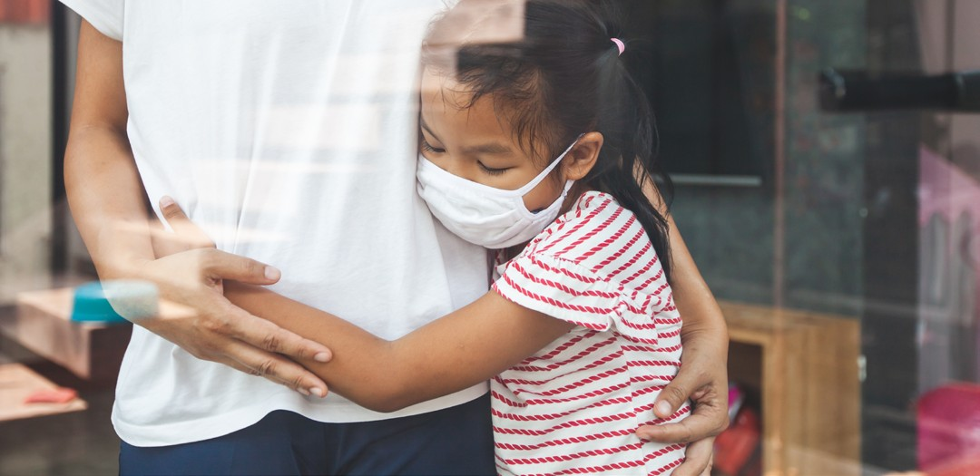

Identify resources that can be shared by staff with families.
- Identify resources for where to get help in the community (e.g., financial assistance, social services, internet access, COVID testing).
- Identify resources on wellness and coping that might be helpful for families.
Tips for Supporting Yourself During the Pandemic12
Tips for Supporting Yourself During the Pandemic (Spanish)13
- Share Pyramid Model information with families – the returning families will appreciate the reminder and new families will need the orientation.
We Have Something Important to Share with You!14
We Have Something Important to Share with You! (Spanish)15
- Create a template for information about classroom staff (both current and new) to share with families. Include photos of staff wearing masks.

Considerations for Supporting Relationships with Children

Prioritize relationship building with children instead of moving right back into more demanding activities.

Brainstorm with teachers to provide strategies for welcoming children back to classroom and reconnecting with children. For example:
- Ensure teachers have a way of warmly welcoming all children.
- Build in time to individually check-in with children about topics outside of school

- Review where within the day can teachers embed relationship-building:
  - Welcome song.
  - Morning ritual.
  - Arrival celebration.

Develop strategies that might be used for children who have gaps in attendance due to their illness or contact with someone who is ill.
- Provide web link to classroom morning meetings or activities for children who are at home.
- Share activities for families to do at home.
- Provide virtual check-in with the child from the teacher and peers (e.g., phone call, email, web meeting).

Provide some strategies or develop a ritual to help children feel comfortable with a new caregiver if classroom staffing arrangements have to change due to staff who become ill.

Strategies might include:
- a welcome song that is always used if a child moves to another room;
- a scripted story about having a substitute or new teacher
- having children move their photo with them to a new classroom to provide reassurance that they are welcomed into the new classroom;
- providing a highly preferred activity when children are moved to a different classroom to help them settle in and become comfortable;
- and a staff bulletin board with photos that children can review to get to know all staff in the program.

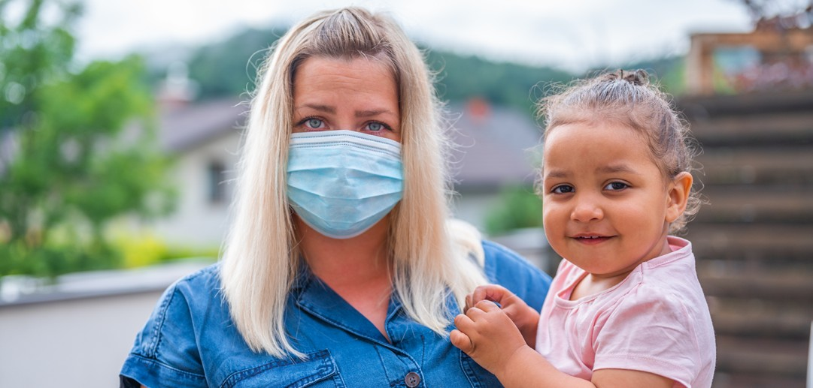
Classroom Environments

Considerations for Classroom Environments
- Your local childcare licensing guidelines, your funding agency, or your program will have guidance that affects the classroom environment, materials, and arrangement. In addition, the leadership team should consider how to help teachers in implementing Teaching Pyramid environmental practices that promote children’s social and emotional competence and understanding of expectations.
CA Teaching Pyramid Classroom Materials16

Have teachers review some back to the basics of Pyramid Model.
Rebuilding the Pyramid: Reconnecting After a Break17
Re-Connecting and Building Relationships with Infants18

Work with families and teachers to gather and post family photos in the classroom at heights where children can see them. Make sure each child can find a posted photo of their family.

Guide teachers about the importance of creating a safe and predictable environment.
- Review new rules and routines as a result of the pandemic. You might be making changes in transition strategies, arrival, naptime or other routines.
- Ask teachers to develop a plan for how they will teach new routines and rules to children.
- Work with staff to identify materials or resources that might be needed to teach and remind children of new routines or rules (e.g., new visuals, posters, scripted stories).
- Ask teachers to increase the frequency of schedule and expectations review throughout the day and provide coaching support to assist teachers in helping children learn new routines.
- Remind all staff that the more time they spend on teaching and practicing new routines, the less time they will have to spend on redirecting or responding to children’s challenging behavior during the new routines.
Challenging behavior during the new routines might suggest the routine needs to be strengthened or re-taught.








- Help teachers identify where they can connect expectations and rules to changes in routines or procedures. For example, link washing hands or spacing out the line to the expectation of “Be Safe.”
wave hello
saluda con la mano
elbow bump
choca los codos
give a thumbs up blow a kiss
da un pulgar hacia arriba sopla un beso
put hands on your heart give an air hug give a superhero salute pon las manos da un abrazo de aire da una saludo sobre tu corazón de superhéroe
smile
sonríe
Greetings | Saludos
- Assist teachers in developing new ways to conduct greetings with children as they enter the classrooms to adhere to CDC guidance. Ensure teachers have a plan to teach children how to greet and the materials to support instruction.
Greeting Choice Board for Social Distancing19

Discuss the need to use positive directions with children.
- Emphasize the importance of positive directions. Remind teachers to tell children what to do rather than what not to do.
- Help staff develop new phrases for positively stating directions they have not had to consider before. For example, “Don’t take off your masks” can be phrased, “Masks stay on our face in the classroom.”

Remind teachers of the importance of positive descriptive acknowledgement.
- Coach on ways to increase the use of positive descriptive acknowledgement (PDA). Children will benefit from hearing from their teachers what they are doing well.
- Offer some strategies for teachers to increase their use of positive descriptive acknowledgement (PDA).
Some Starters for Giving Positive Feedback and Encouragement20.
- Some ideas include: 1) Determining how many times you want to give positive descriptive acknowledgement in an activity and putting that many bracelets or rubber bands on your wrist. Everyone time you provide one, move the bracelet; 2) Challenge yourself to provide 1 more acknowledgement statement after each one you provide by looking for a child doing something similar; and 3) Posting positive descriptive acknowledgement sentence starters around the room as reminders.

Remind teachers that children might be anxious, distracted, or have lower frustration thresholds. Strategies to use to ease children back into routines might include:
- Offering more choices.
- Reducing expectations for time on task.
- Checking in frequently with children about their emotional state.
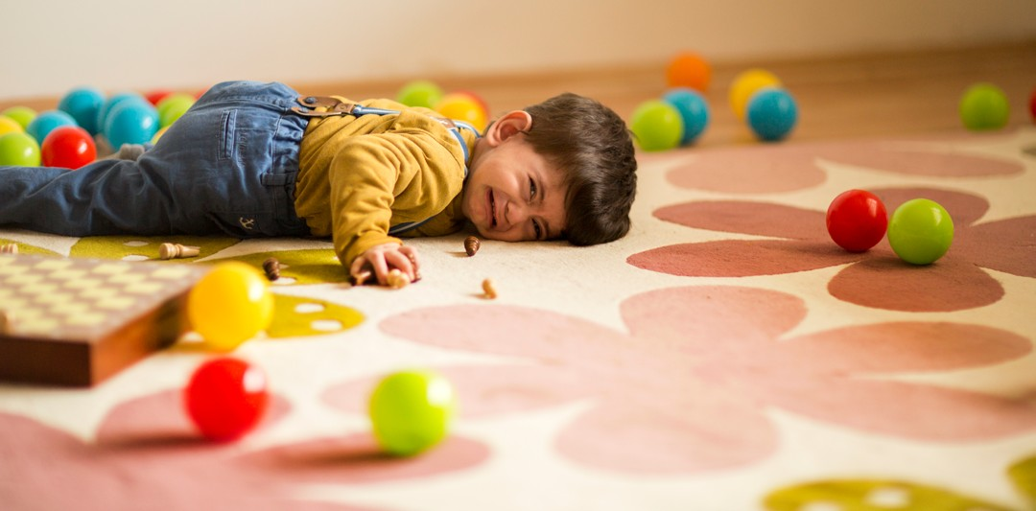
- Providing children with extra support during routines such as transitions and clean up.

Promoting Social Emotional Skills and Responding to Challenging Behavior

Considerations for Teaching Social Emotional Skills, Preventing Challenging Behavior, and Responding to Children When Challenging Behavior Occurs










The leadership team should provide guidance to teachers about the need to increase their support for helping children identify and express their emotions, use self-regulation and social problem- solving skills, and interact with others.
Frustrated  Frustrado(a) | Excited  Emocionado(a) | Lonely  Solitario(a) | Sad  Triste
Mad  Enojado(a) | Today, I feel...  Hoy me siento... |  | Nervous  Nervioso(a)
Happy  Feliz | Loved  Amado(a)/Querido(a) | Scared  Asustado(a) | Proud  Orgulloso(a)

CA Teaching Pyramid Teaching Social Emotional Skills21

We can expect that children might have difficulty with separation from caregivers, changes in classroom routines and procedures, or have increased stress or emotional vulnerability.

Establish an expectation that all classrooms will do a “feelings check-in.”
Feeling Faces: This is how I feel today! Chart and Template (English-Spanish)22

Ask teachers to make emotional literacy a priority in their classroom (e.g., circle will focus on feelings and emotions). Determine as a team how to support teachers to do this.

If program staff will be wearing masks, have teachers think about using more hand gestures and body language when interacting with children. Ask teachers to help children focus on body language, hand gestures, and small facial movements like eyes and eyebrows when identifying emotions.
Helping Children Understand Emotions When Wearing Masks23

Have teachers review how they teach self-regulation in their classrooms.
- Ensure that all teachers of toddlers and preschool children have a calming area where children can choose to go when feeling anxious or stressed. Review how to teach children when and how to use it.
- Provide guidance to teachers on the importance of using co-regulation and teaching self-regulation skills including offering a regular review of the strategies and opportunities to practice.
- Have teachers identify resources or materials they will use to effectively teach self-regulation (e.g., Tucker Turtle, visual prompts).






The Turtle Technique24
Blow the pinwheel
Smell the flower
Take a Deep Breath
The Turtle Technique (Spanish)25
Tucker Turtle Takes Time to Tuck and Think26
Tucker Turtle Takes Time to Tuck and Think (Spanish)27
Relaxation Thermometer28
Self-Regulation Skills: Breathing Strategies29

As a team, review the process for supporting teachers who need assistance with a child or children in their classroom. Remind teachers that traumatic events related to the pandemic might affect some children's behavior resulting in the need for individualized interventions.
- Identify some strategies teachers might use until a plan has been written to help the child become calm and stay safe.
CA Teaching Pyramid Module 3: Individualized Interventions

Review ways for teachers to talk to families regarding behavioral concerns.

Ensure teachers understand the collaborative process for developing a behavior support plan.

As a team, identify community resources available for families with young children as it relates to trauma. These may be resources for families to access or resources teachers might use to address individualized interventions as it relates to the child’s experiences.

Embedded Hyperlinks
- Communicating with Families: Helpful Suggestions. https://cainclusion.org/resources/tp/materials/walking-up-the-pyramid/relationships/For Families or Communicating with Families/Communicating-with-Families.pdf
- I Can Be Safe and Healthy by Washing My Hands!. https://cainclusion.org/resources/tp/materials/walking-up-the-pyramid/environments/washing-hands_story.pdf
- I Can Be Safe and Healthy by Washing My Hands! (Spanish). https://cainclusion.org/resources/tp/materials/walking-up-the-pyramid/environments/washing-hands_story_sp.pdf
- Wearing Masks. https://cainclusion.org/resources/tp/materials/walking-up-the-pyramid/environments/Wearing-Masks_Story.pdf
- Wearing Masks (Spanish). https://cainclusion.org/resources/tp/materials/walking-up-the-pyramid/environments/Wearing-Masks_Story_SP.pdf
- Taking Care of Yourself. https://cainclusion.org/resources/tp/materials/walking-up-the-pyramid/workforce/Taking-Care-of-Yourself.pdf Taking-Care-of-Yourself.pdf
- Providers: Taking Care of Ourselves. https://cainclusion.org/resources/tp/materials/walking-up-the-pyramid/workforce/TakingCare_ProviderBk_final.pdf
- Transitioning Back to the Program: Connecting with Families.
https://cainclusion.org/resources/tp/materials/walking-up-the-pyramid/environments/Transitioning-Back-Connecting-w-Families.pdf
- My Teachers Want to Know. https://cainclusion.org/resources/tp/materials/walking-up-the-pyramid/relationships/For Families or Communicating with Families/My-teacher-wants-to-know_WelcomeBack.pdf
- My Teachers Want to Know (Spanish). https://cainclusion.org/resources/tp/materials/walking-up-the-pyramid/relationships/For Families or Communicating with Families/My-teacher-wants-to-know_WelcomeBack_SP.pdf
- Understanding Adverse Childhood Experiences (ACES). https://cainclusion.org/resources/tp/materials/walking-up-the-pyramid/trauma-informed/ACESHandoutForParents.pdf
- Tips for Supporting Yourself During the Pandemic. https://cainclusion.org/resources/tp/materials/walking-up-the-pyramid/relationships/For Families or Communicating with Families/Pandemic_Supporting-Yourself_tipsheet.pdf
- Tips for Supporting Yourself During the Pandemic (Spanish). https://cainclusion.org/resources/tp/materials/walking-up-the-pyramid/relationships/For Families or Communicating with Families/Pandemic_Supporting-Yourself_tipsheet_SP.pdf
- We Have Something Important to Share with You!. https://cainclusion.org/resources/tp/materials/walking-up-the-pyramid/relationships/For Families or Communicating with Families/CA_NCPMI_family_factsheet_web.pdf
- We Have Something Important to Share with You! (Spanish). https://cainclusion.org/resources/tp/materials/walking-up-the-pyramid/relationships/For Families or Communicating with Families/CA_NCPMI_family_factsheet_web_SP.pdf
- CA Teaching Pyramid Classroom Materials. https://cainclusion.org/teachingpyramid/materials/classroom/ Implementation/Program/strategies.html
- Rebuilding the Pyramid: Reconnecting After a Break. https://cainclusion.org/resources/tp/materials/walking-up-the-pyramid/relationships/Rebuilding-the-Pyramid.pdf
- Re-Connecting and Building Relationships with Infants. https://cainclusion.org/resources/tp/materials/walking-up-the-pyramid/relationships/Reconnecting_Infants.pdf
- Greeting Choice Board for Social Distancing. https://cainclusion.org/resources/tp/materials/walking-up-the-pyramid/relationships/Greeting-Board_EN-SP.pdf
- Some Starters for Giving Positive Feedback and Encouragement. https://cainclusion.org/resources/tp/materials/walking-up-the-pyramid/relationships/ToolsBuildingRelationships_starters-for-giving-positive-feedback.pdf
- CA Teaching Pyramid Teaching Social Emotional Skills. https://cainclusion.org/teachingpyramid/walking-up-the-pyramid/#supports
- Feeling Faces: This is how I feel today! Chart and Template (English-Spanish). https://cainclusion.org/resources/tp/materials/walking-up-the-pyramid/supports/FeelingFaces_chart_EN-SP.pdf
- Helping Children Understand Emotions When Wearing Masks. https://cainclusion.org/resources/tp/materials/walking-up-the-pyramid/supports/Wearing-Masks_Tipsheet.pdf
- The Turtle Technique. https://cainclusion.org/resources/tp/materials/walking-up-the-pyramid/supports/TurtleTechnique_steps.pdf
- The Turtle Technique (Spanish). https://cainclusion.org/resources/tp/materials/walking-up-the-pyramid/supports/TurtleTechnique_steps_sp.pdf
- Tucker Turtle Takes Time to Tuck and Think. https://cainclusion.org/resources/tp/materials/scripted-stories/TuckerTurtleStoryAdapted_June2012.pptx
- Tucker Turtle Takes Time to Tuck and Think (Spanish). https://cainclusion.org/resources/tp/materials/scripted-stories/TuckerTurtleStoryAdapted_May2013_Spanish.pptx
- Relaxation Thermometer. https://cainclusion.org/resources/tp/materials/walking-up-the-pyramid/supports/relaxation-thermometer-2020.pdf
- Self-Regulation Skills: Breathing Strategies. https://cainclusion.org/resources/tp/materials/walking-up-the-pyramid/supports/Smell-Blow.pdf

