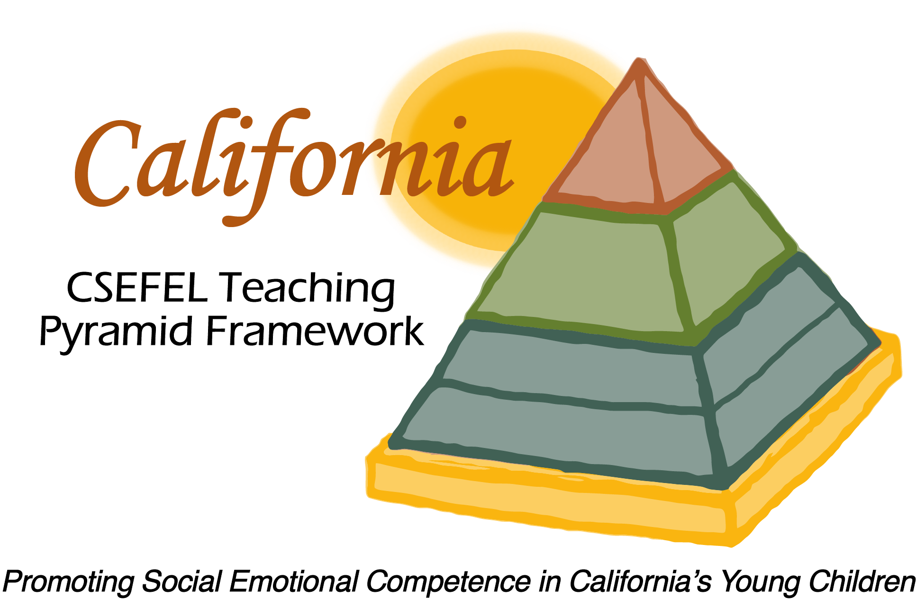

Verification of Hours Spent on a Professional Growth Activity

Title of the Activity:

Webinar II: Designing Supportive Environments

Description of the Activity:

This WebEx training, provided for Partner Sites of the CA CSEFEL Teaching Pyramid, covered different professional development tools available to help teachers create supportive environments and included virtual tours of three Partner Site classroom environments.

Dates of Activity:
January 12, 2016

Number of Training Hours:
1 Hour

Session Sponsor:

California Collaborative on the Social & Emotional Foundations For Early Learning

Project Director:
Linda Brault
Participant:

