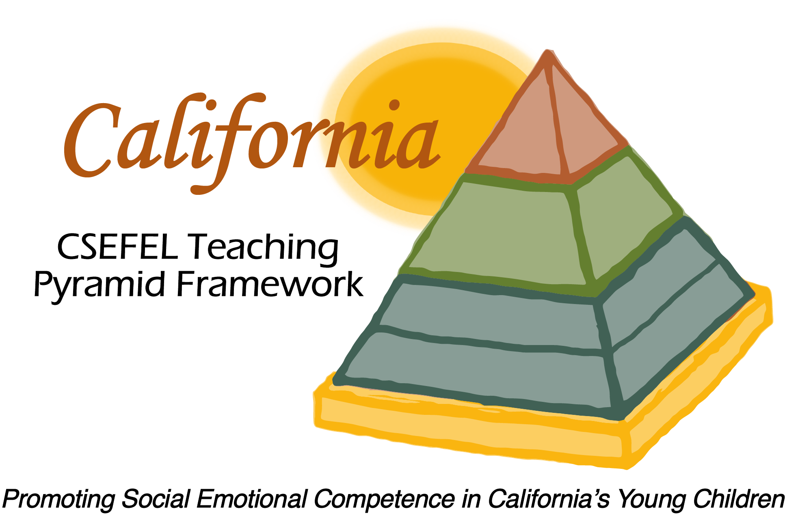

Verification of Hours Spent on a Professional Growth Activity

Title of the Activity:

Authorized Coaches for CA CSEFEL Teaching Pyramid:

Growing in Coach Competencies: Understanding the Flow of the Coach Conversation and the Use of the Standing Agenda

Description of the Activity:

This webinar was conducted by the WestEd Partner Site Team of the WestEd Center for Child & Family Studies. This webinar focused on competencies of authorized coaches for the CA CSEFEL Teaching Pyramid.

Dates of Activity:
December 20, 2016

Number of Training Hours:
1 Hour

Session Sponsor:

California Collaborative on the Social & Emotional Foundations For Early Learning
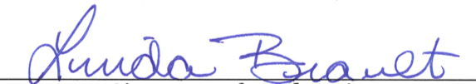
Project Director:
Linda Brault
Participant:

