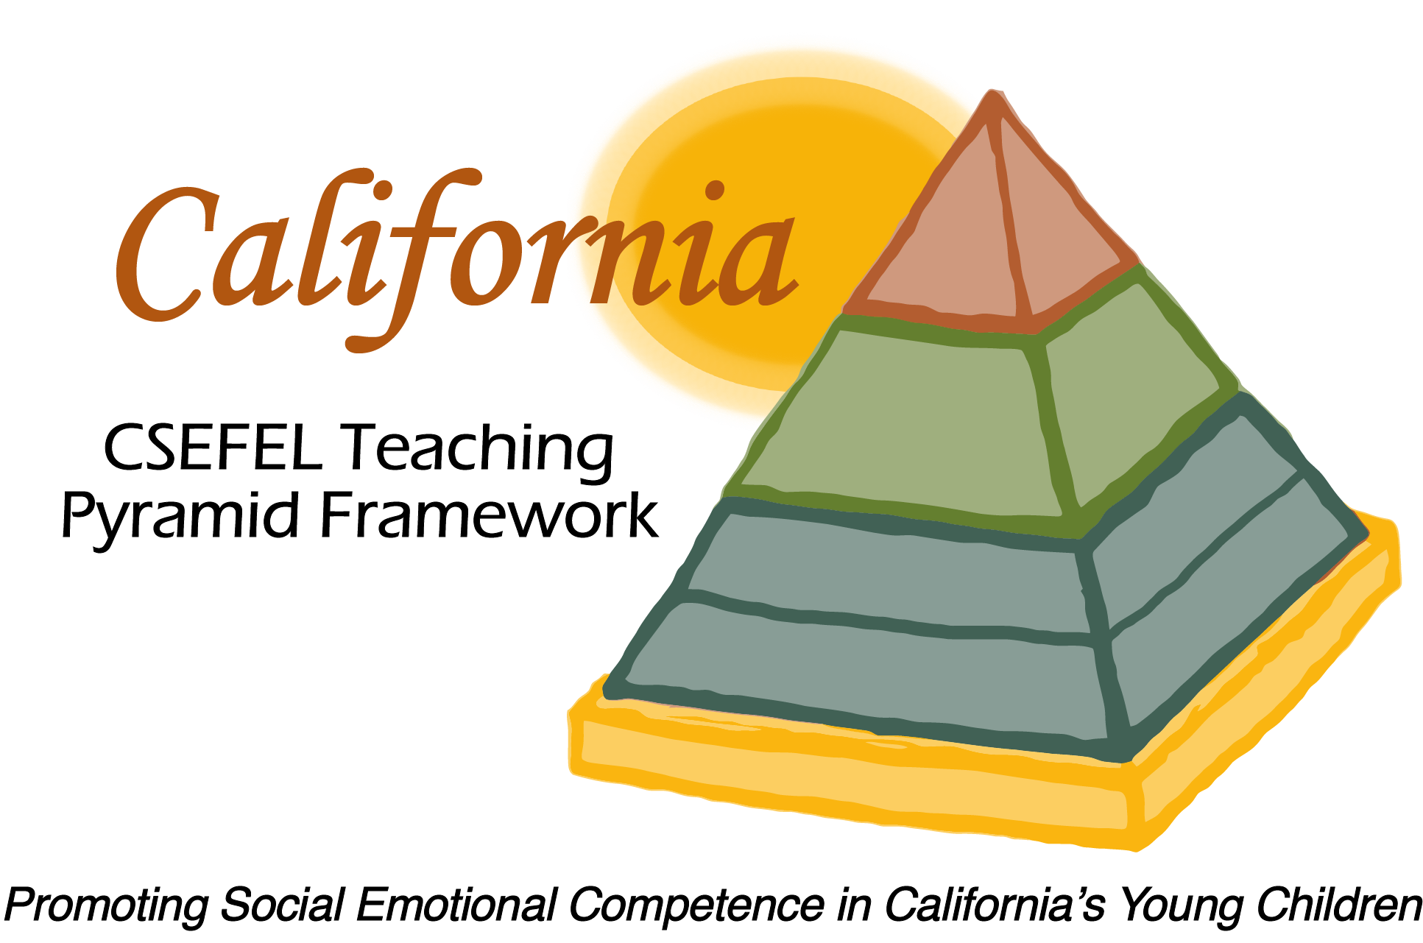

**Verification of Hours Spent on a Professional Growth Activity**

Title of the Activity:

|  |
| --- |
| **The Teaching Pyramid:** **Reflective Training Conversation** |

Description of the Activity:

Technical Assistance Conference Call with Open Conversation and Reflective Format facilitated by Julie Kurtz, LMFT

Dates of Activity:

February 10, 2016

Number of Training Hours:

1 Hour

Session Sponsor:

|  |  |
| --- | --- |
| California Collaborative on the Social & Emotional Foundations For Early Learning | |
| Picture 5Project Director: | |
| **Linda Brault** |  |
|  |  |

Participant: