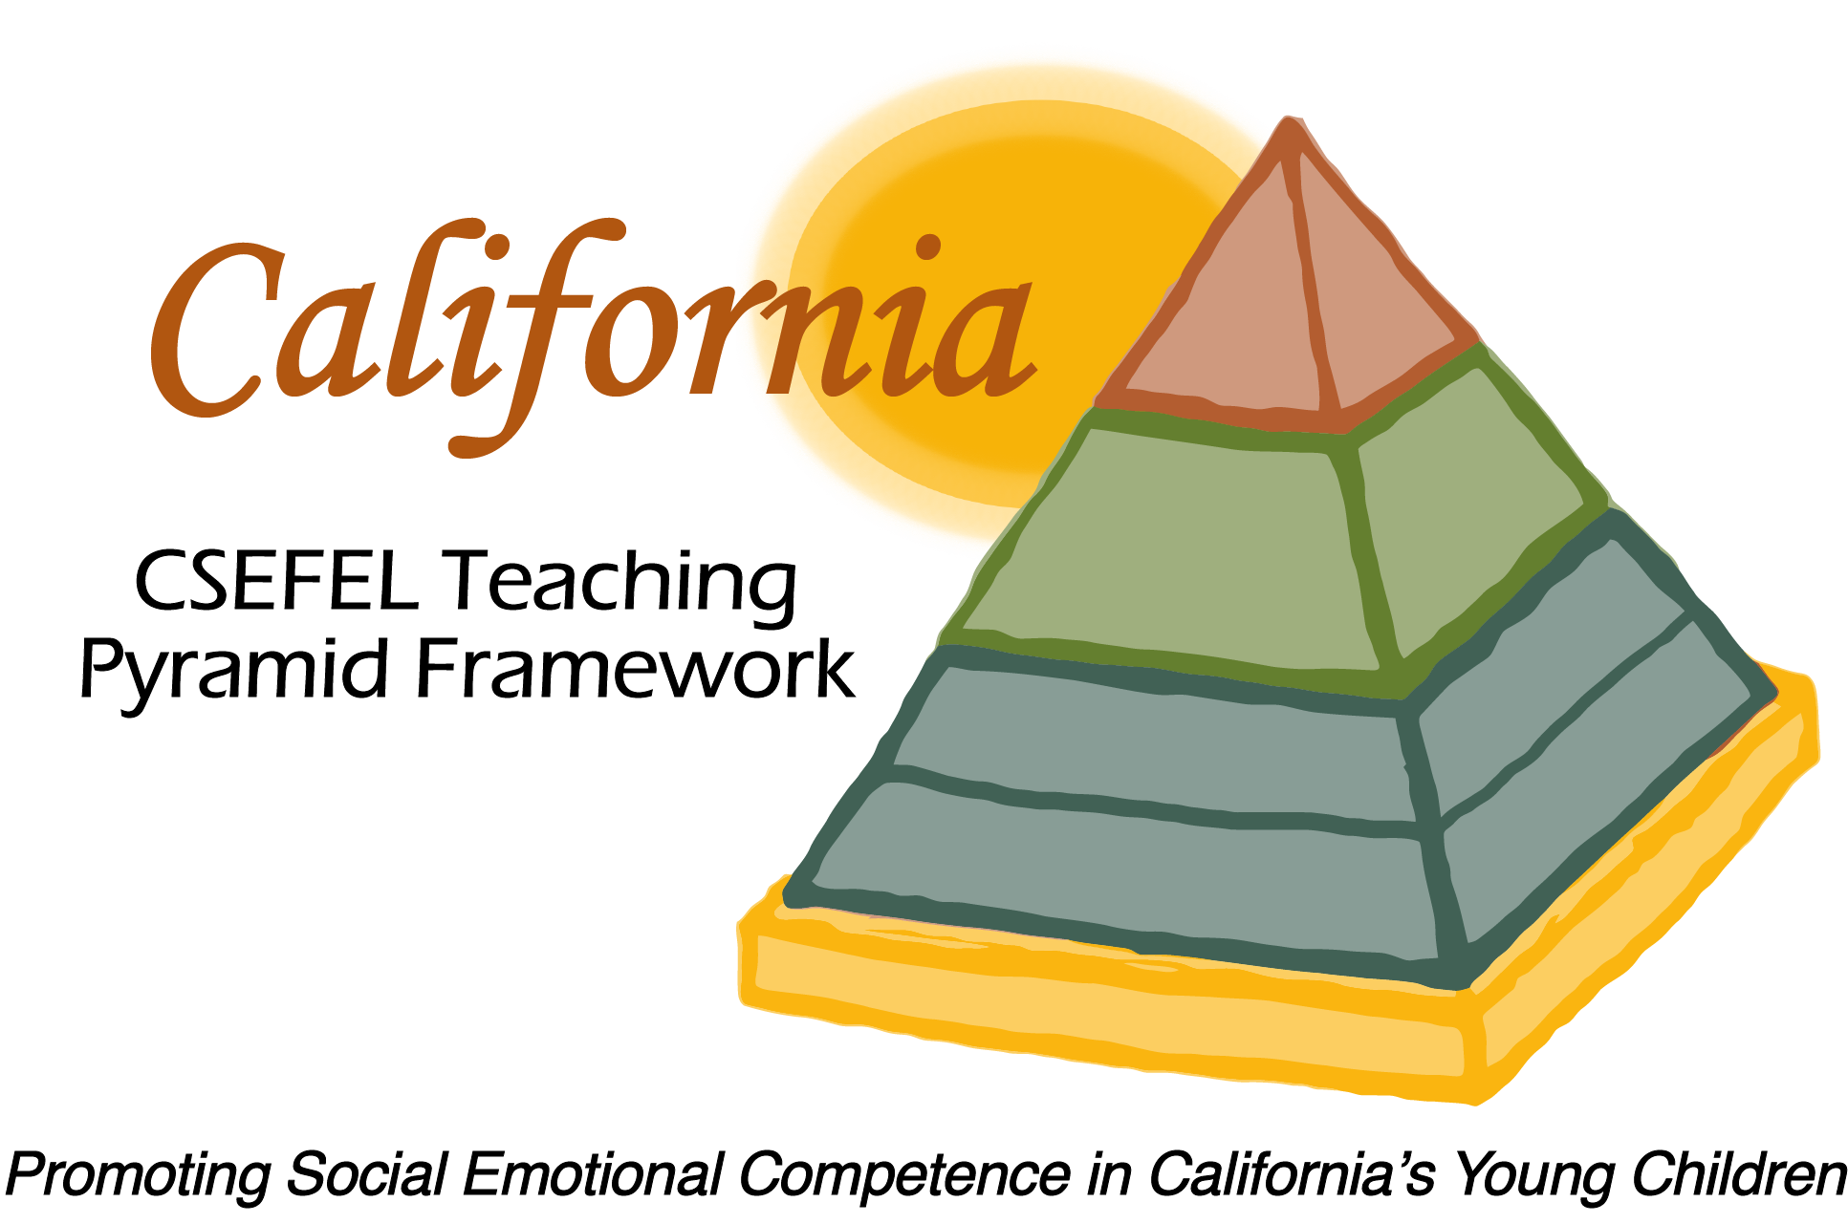

Verification of Hours Spent on a Professional Growth Activity

Title of the Activity:

The Teaching Pyramid:

Updates to the 2016-17 Preschool Modules

Description of the Activity:

This WebEx training covered 2016-2017 updates to Modules1a, 1b, 2, 3a and 3b of the CA CSEFEL Teaching Pyramid for Preschool.

Dates of Activity:
August 31, 2016

Number of Training Hours:
30 Minutes

Session Sponsor:

California Collaborative on the Social & Emotional Foundations For Early Learning
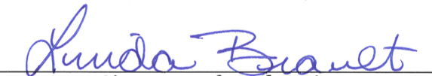
Project Director:
Linda Brault
Participant:

