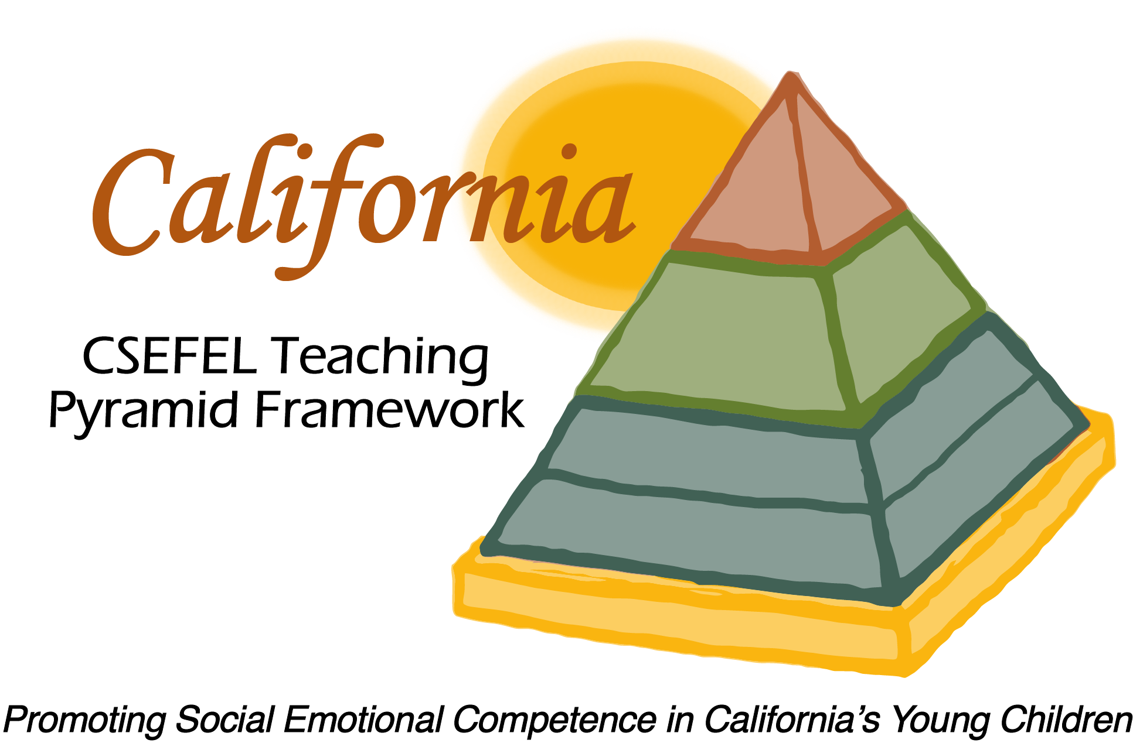

Verification of Hours Spent on a Professional Growth Activity

Title of the Activity:

The Teaching Pyramid: Orientation for Newly Authorized

And Updates to the 2016-17 Preschool Modules

Description of the Activity:

This WebEx training covered basic information regarding authorization parameters for CA CSEFEL Teaching Pyramid authorized trainers and coaches and ongoing support for authorized trainers and coaches during the 2016-2017 year. It also introduced people to the changes made to the 2016-2017 year Preschool Teaching Pyramid Training Materials.

Date of Activity:
August 31, 2016

Number of Training Hours:
1 Hour

Session Sponsor:

California Collaborative on the Social & Emotional Foundations For Early Learning
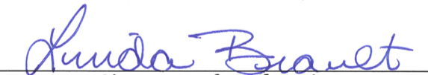
Project Director:
Linda Brault
Participant:

