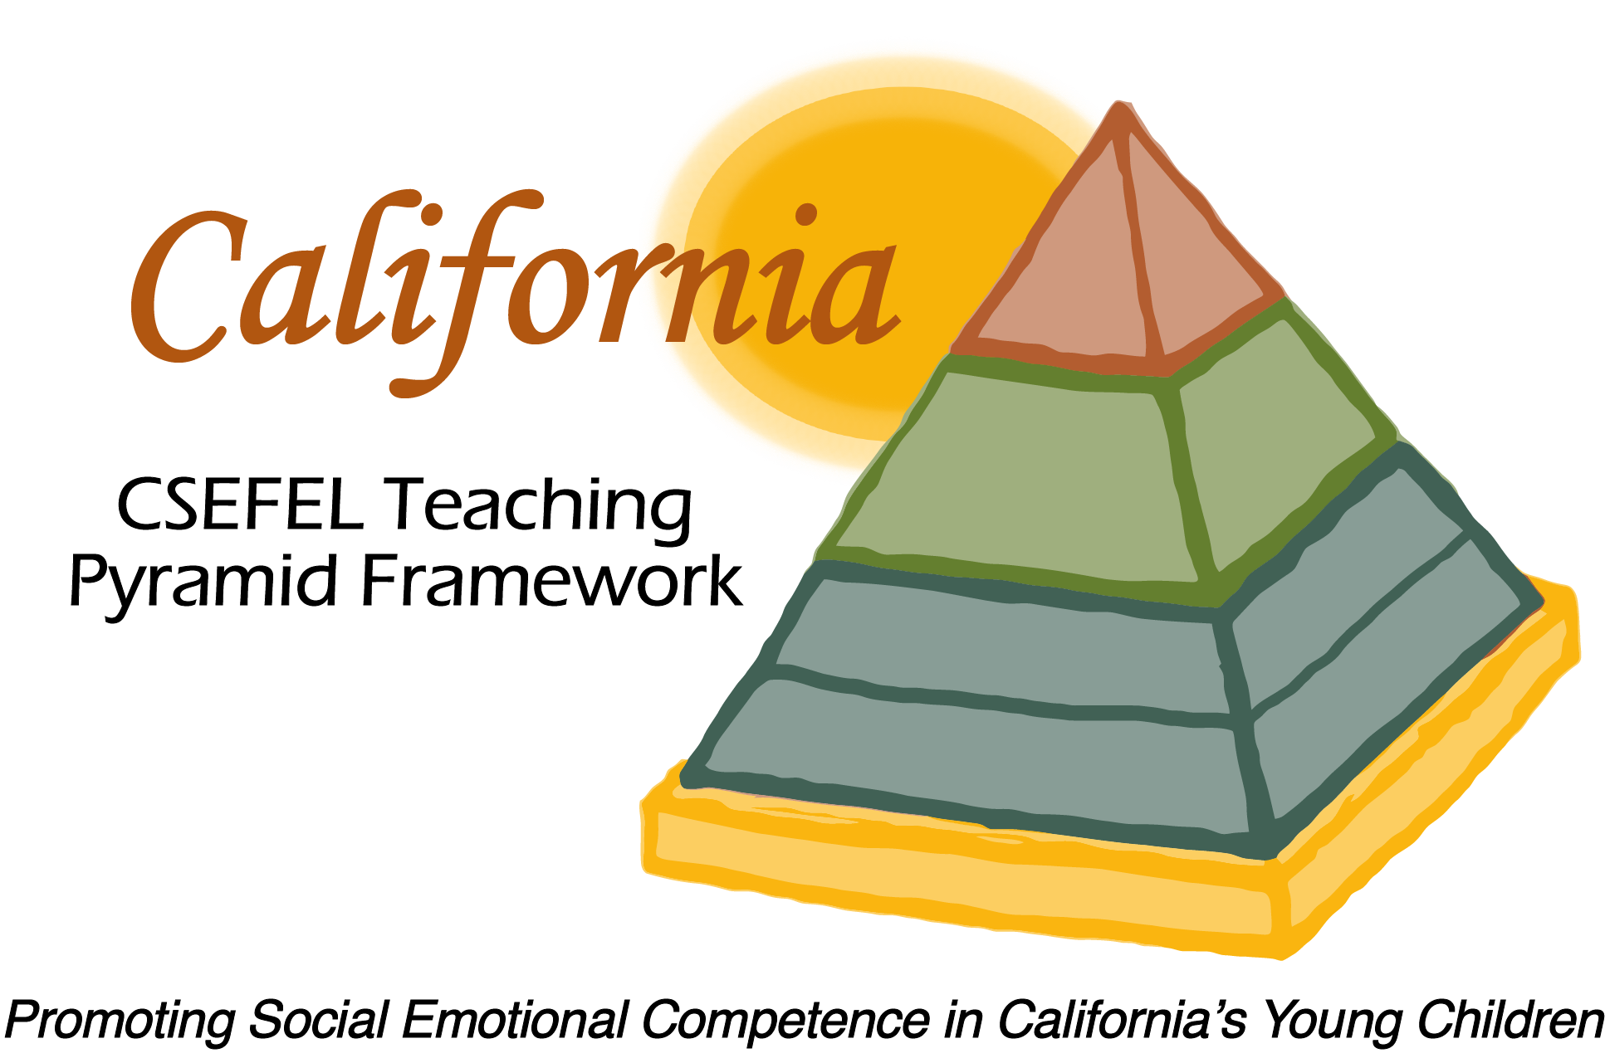

Verification of Hours Spent on a Professional Growth Activity

Title of the Activity:

The Teaching Pyramid:

Orientation to Authorization and Materials Update

Description of the Activity:

This WebEx training covered basic information regarding authorization parameters for CA CSEFEL Teaching Pyramid authorized trainers and coaches. It also introduced people to updates to the Teaching Pyramid for Preschool materials for the 2014-2015 year.

Dates of Activity:
August 26, 2014

Number of Training Hours:
1 Hour

Session Sponsor:

California Collaborative on the Social & Emotional Foundations For Early Learning
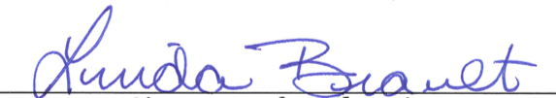
Project Director:
Linda Brault
Participant:

