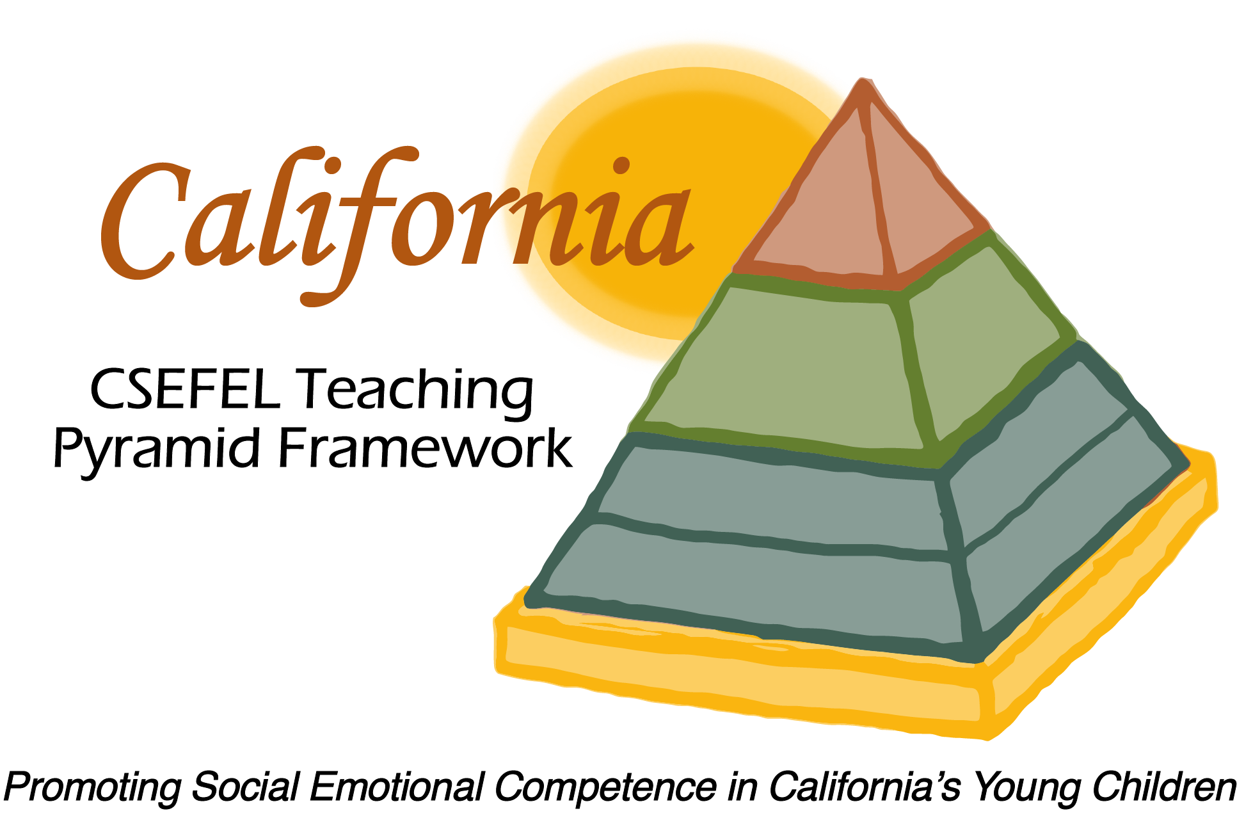

Verification of Hours Spent on a Professional Growth Activity

Title of the Activity:

The Teaching Pyramid:

Coaching on Updated Modules 1 & 2

Description of the Activity:

This webinar focused on coaching on the updates and modifications in the Teaching Pyramid materials for Module 1 and Module 2 for 2014-2015.

Dates of Activity:
October 28, 2014

Number of Training Hours:
1 Hour

Session Sponsor:

California Collaborative on the Social & Emotional Foundations For Early Learning

Project Director:
Linda Brault
Participant:

