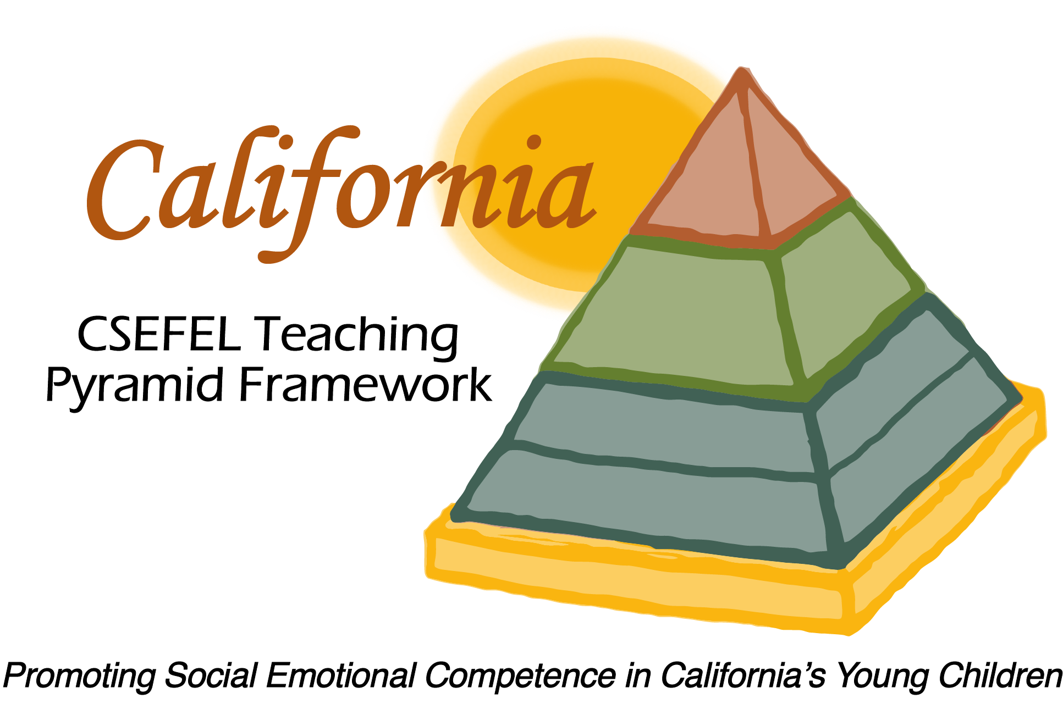

Verification of Hours Spent on a Professional Growth Activity

Title of the Activity:

Exploring CA CSEFEL Teaching Pyramid Guiding Principles and Reflective Questions

Description of the Activity:

This WebEx training, provided for Authorized Coaches of the CA CSEFEL Teaching Pyramid, focused on the Guiding Principles and Reflective Questions utilized in coaching to implementation of the Teaching Pyramid framework.

Dates of Activity:
April 9, 2015

Number of Training Hours:
1 Hour

Session Sponsor:

California Collaborative on the Social & Emotional Foundations For Early Learning

Project Director:
Linda Brault
Participant:

