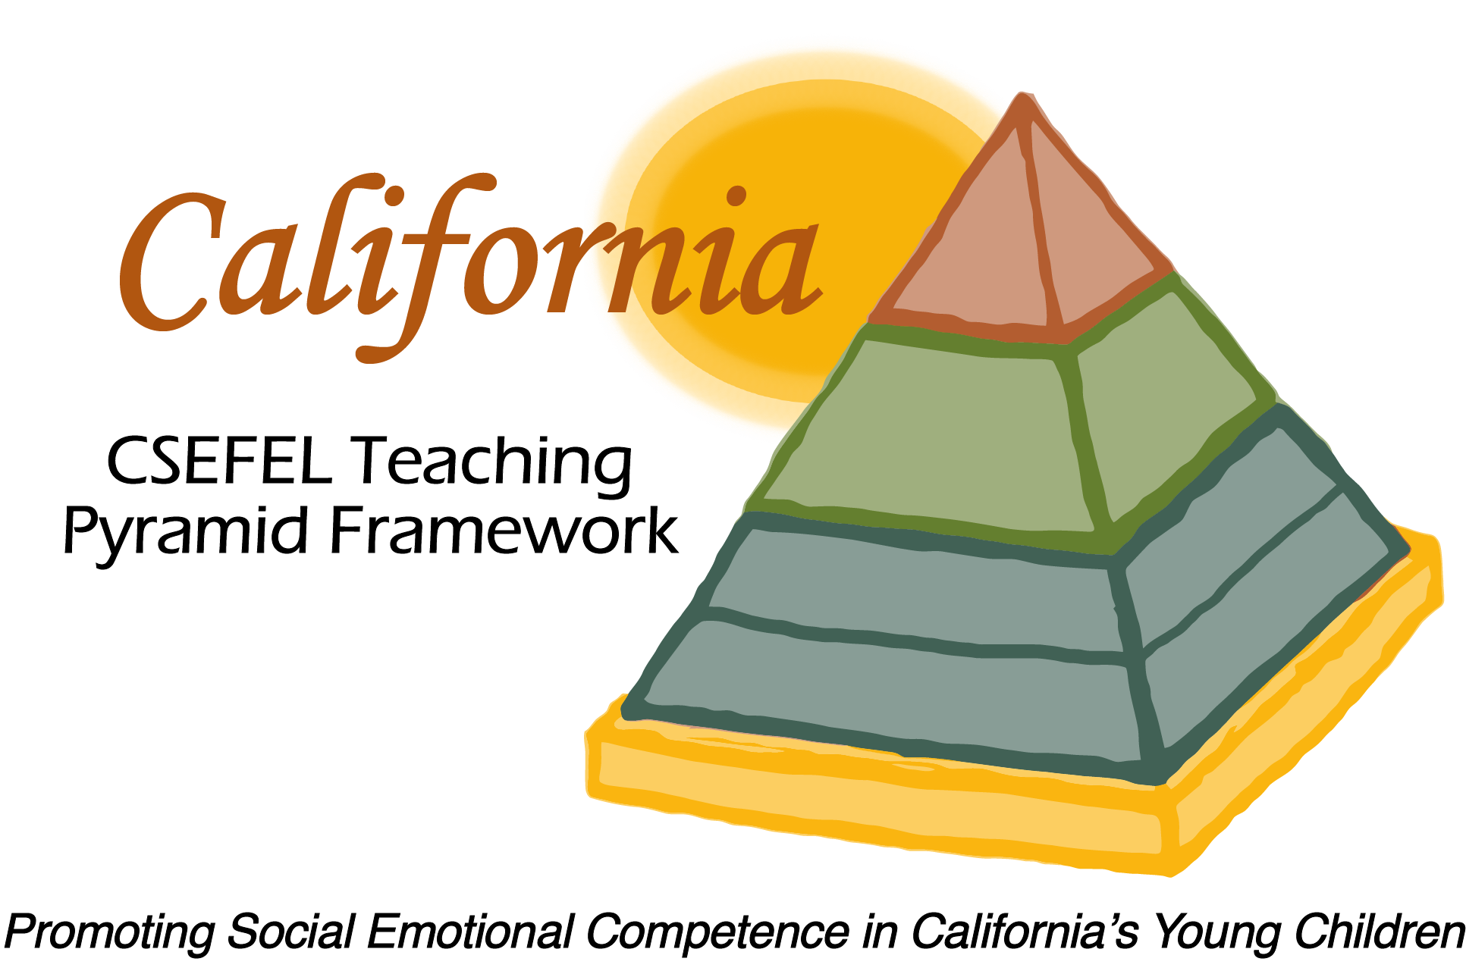

Verification of Hours Spent on a Professional Growth Activity

Title of the Activity:

Technical Assistance for Authorized Trainers

Description of the Activity:

This discussion was facilitated by Julie Kurtz of the WestEd Center for Child and Family Studies and was provided for the Authorized Trainers of the CA CSEFEL Teaching Pyramid. The meeting focused on reflective discussion on training successes, challenges, and deeper learning opportunities experienced while training on the Teaching Pyramid.

Dates of Activity:
April 16, 2015

Number of Training Hours:
1 Hour

Session Sponsor:

California Collaborative on the Social & Emotional Foundations For Early Learning
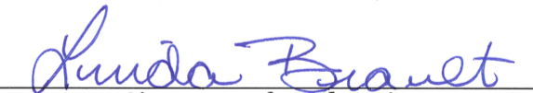
Project Director:
Linda Brault
Participant:

