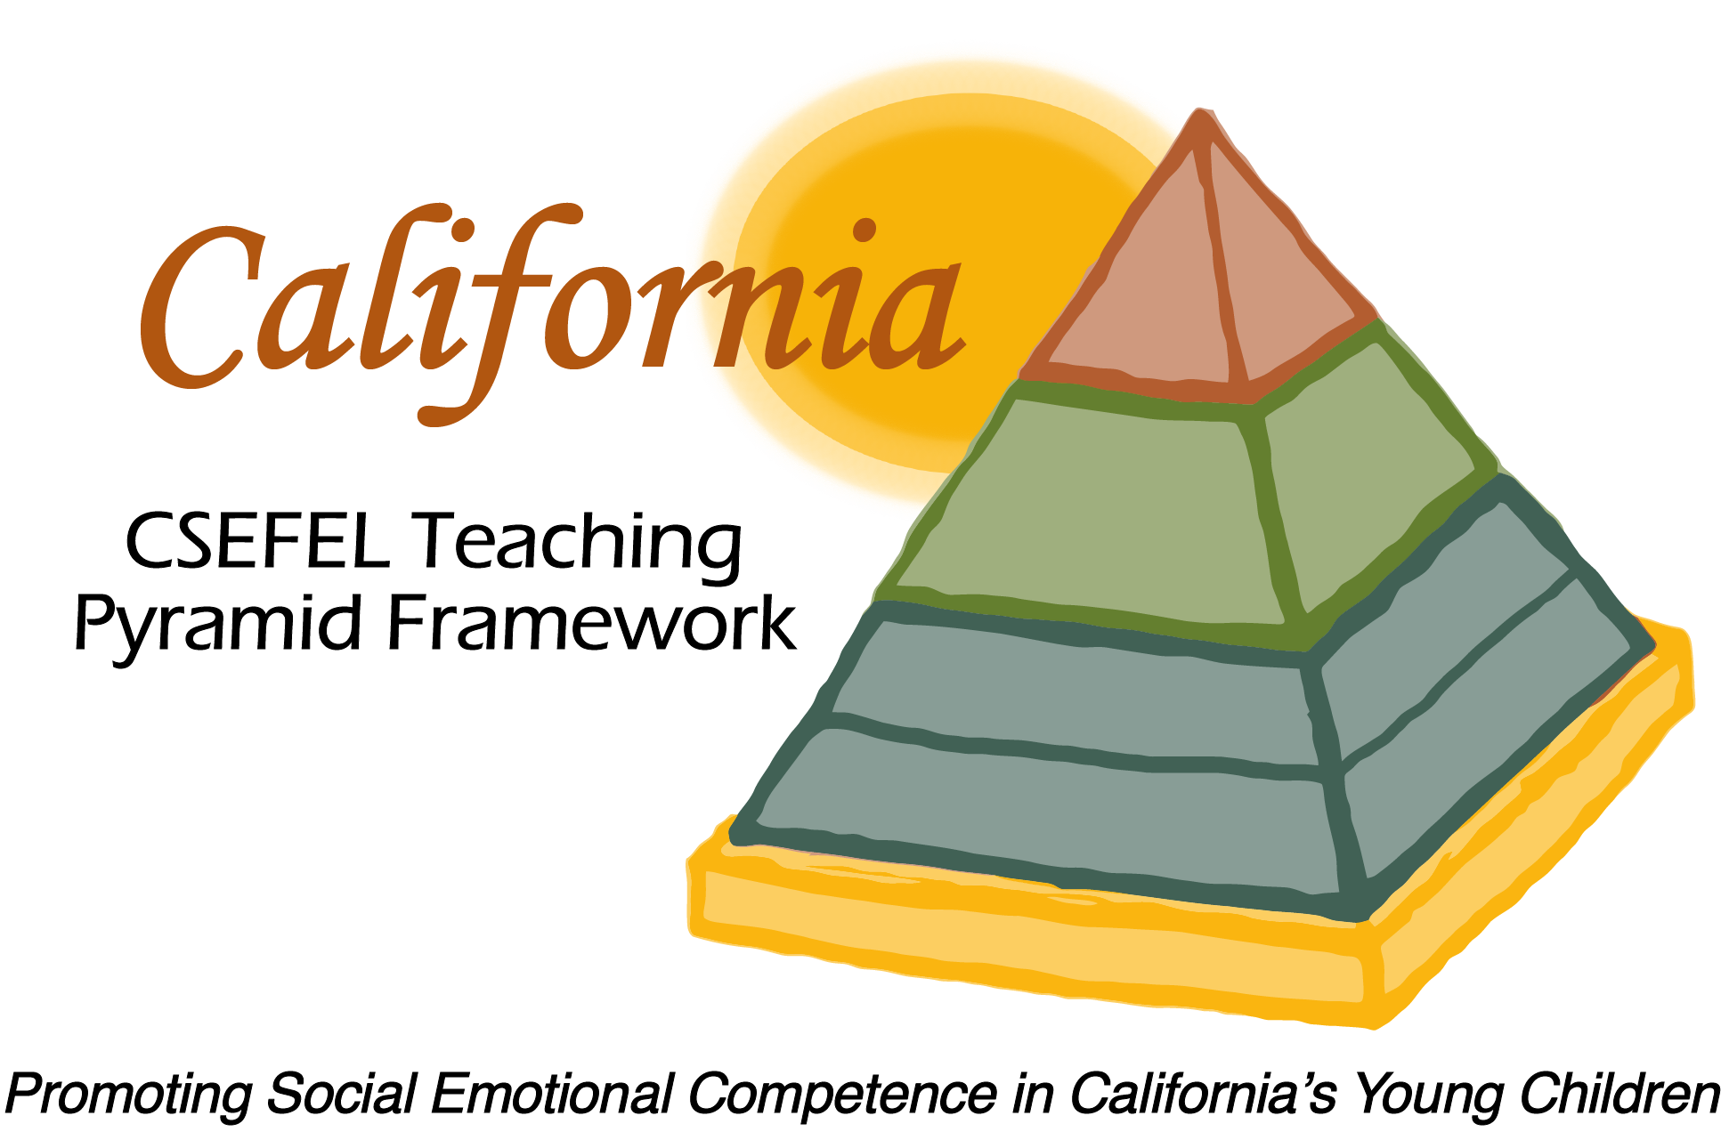

Verification of Hours Spent on a Professional Growth Activity

Title of the Activity:

Providing CA CSEFEL Teaching Pyramid Overviews

Description of the Activity:

This WebEx training, provided for Authorized Trainers of the CA CSEFEL Teaching Pyramid, focused on providing CA CSEFEL Teaching Pyramid Overviews, including short versions and long versions.

Dates of Activity:
June 11, 2015

Number of Training Hours:
1 Hour

Session Sponsor:

California Collaborative on the Social & Emotional Foundations For Early Learning
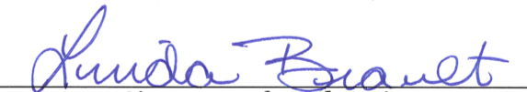
Project Director:
Linda Brault
Participant:

