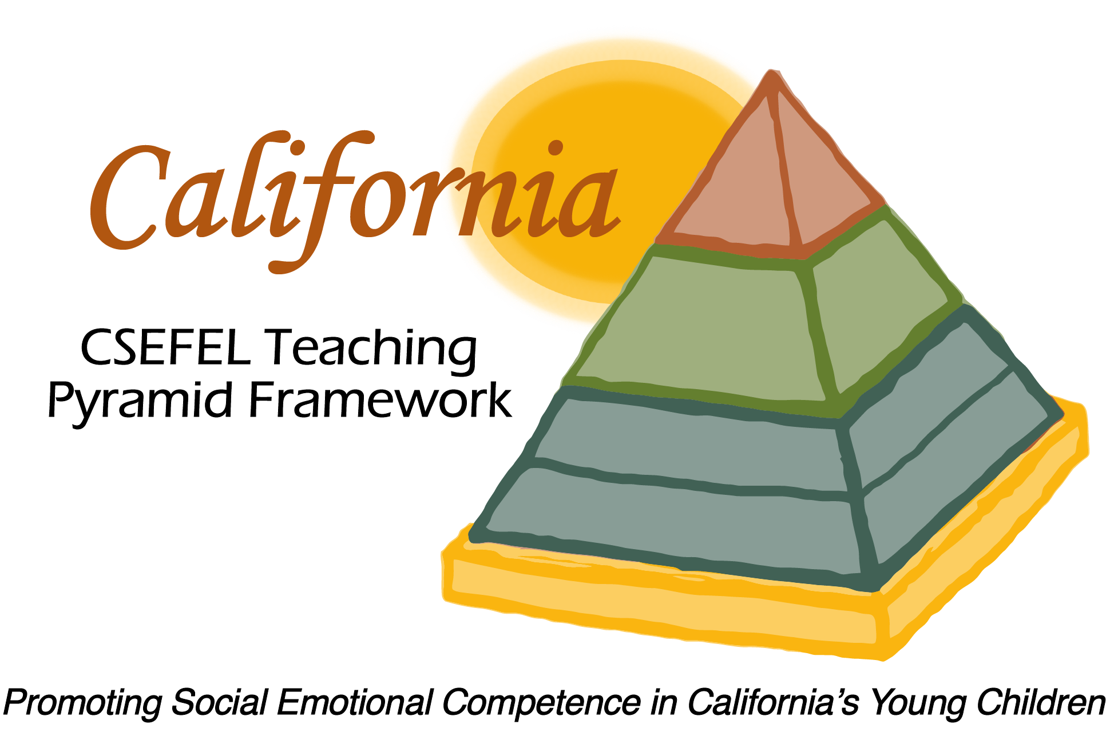

Verification of Hours Spent on a Professional Growth Activity

Title of the Activity:

CA CSEFEL Teaching Pyramid:

2015-16 Module 2 + 1a & 1b Update

Description of the Activity:

This WebEx training covered basic information regarding authorization parameters for CA CSEFEL Teaching Pyramid authorized trainers and coaches. It also introduced people to the ongoing support for authorized trainers and coaches during the 2015-2016 year.

Dates of Activity:
October 19, 2015

Number of Training Hours:
1 Hour

Session Sponsor:

California Collaborative on the Social & Emotional Foundations For Early Learning
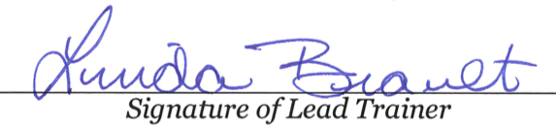
Project Director:
Linda Brault
Participant:

