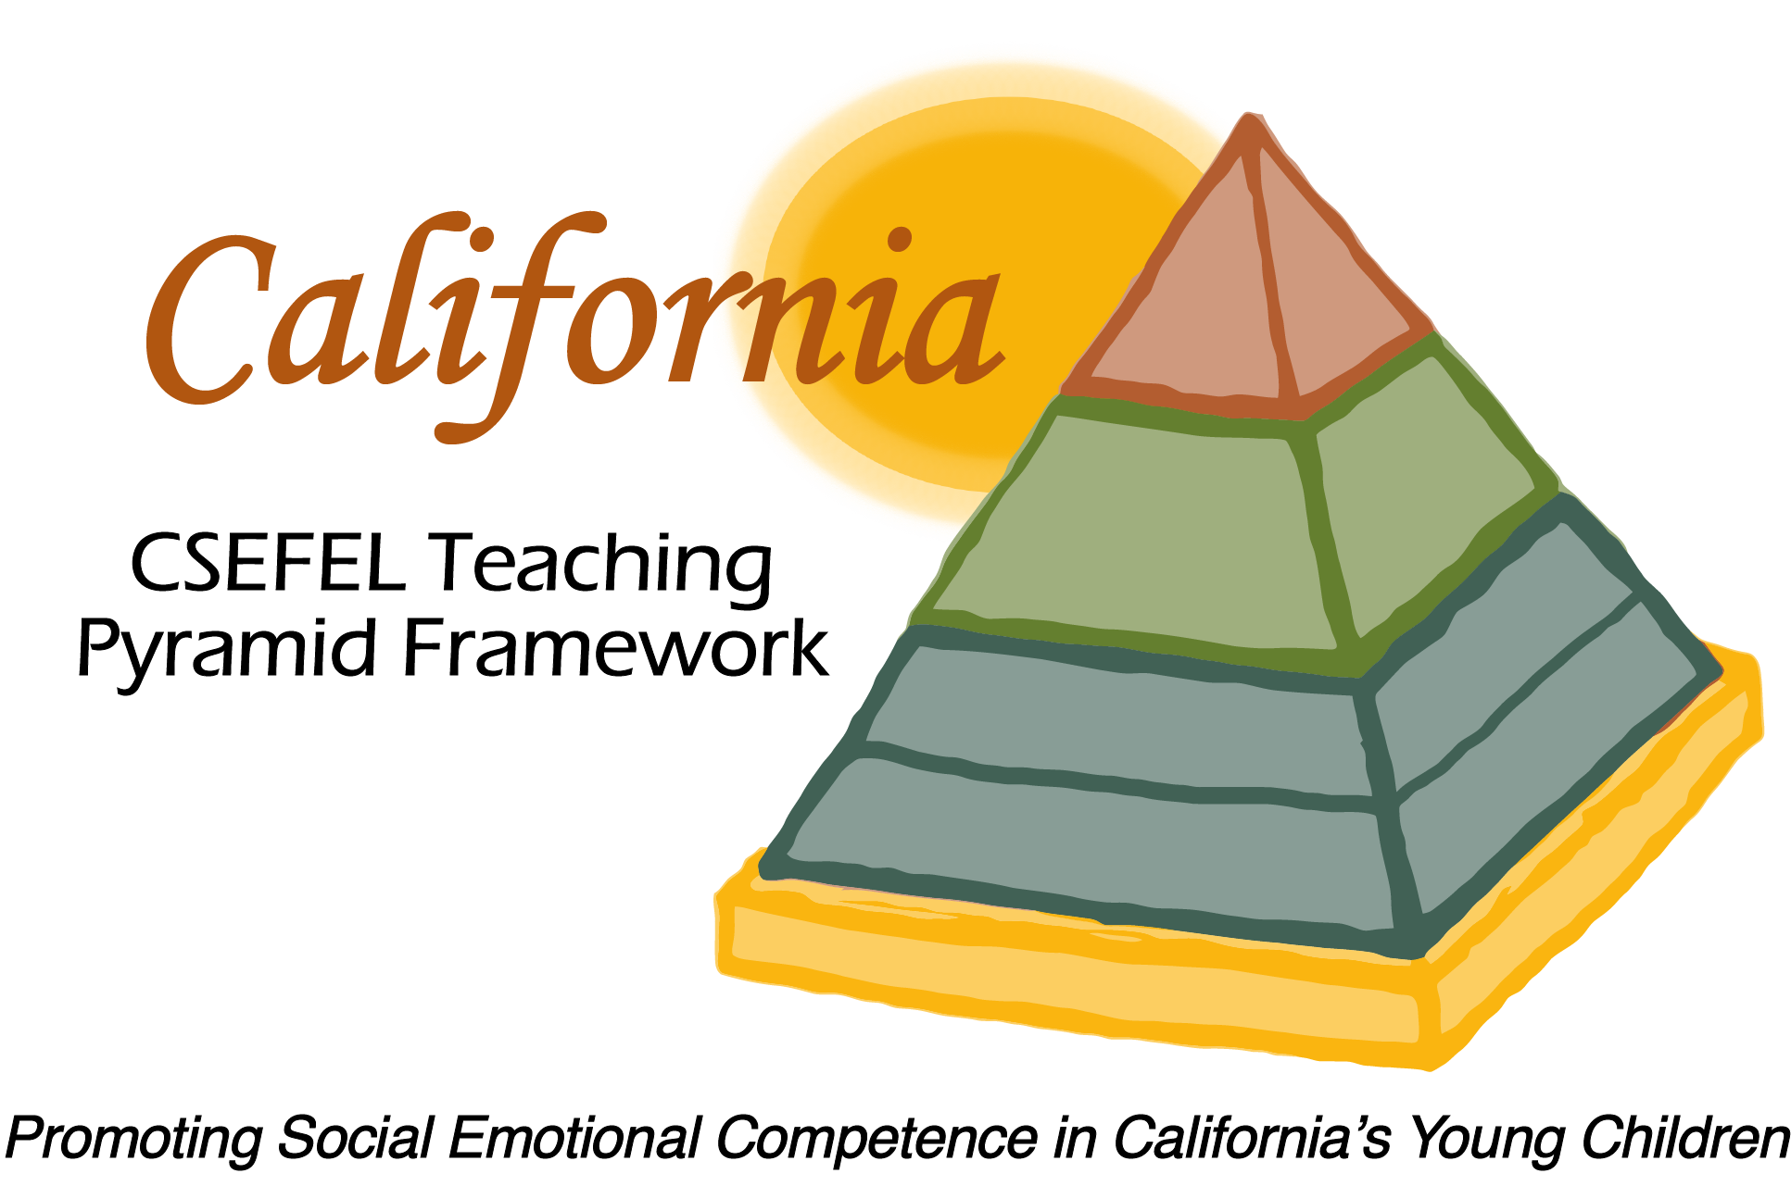

Verification of Hours Spent on a Professional Growth Activity

Title of the Activity:

The Teaching Pyramid Partner Sites Webinar Series:

Building Social Relationships with Families

Description of the Activity:

This webinar was conducted by the WestEd Partner Site Team of the WestEd Center for Child & Family Studies. This webinar focused on strategies for intensive individualized intervention as a means of supporting healthy social-emotional development.

Dates of Activity:
November 10, 2015

Number of Training Hours:
1 Hour

Session Sponsor:

California Collaborative on the Social & Emotional Foundations For Early Learning

Project Director:
Linda Brault
Participant:

