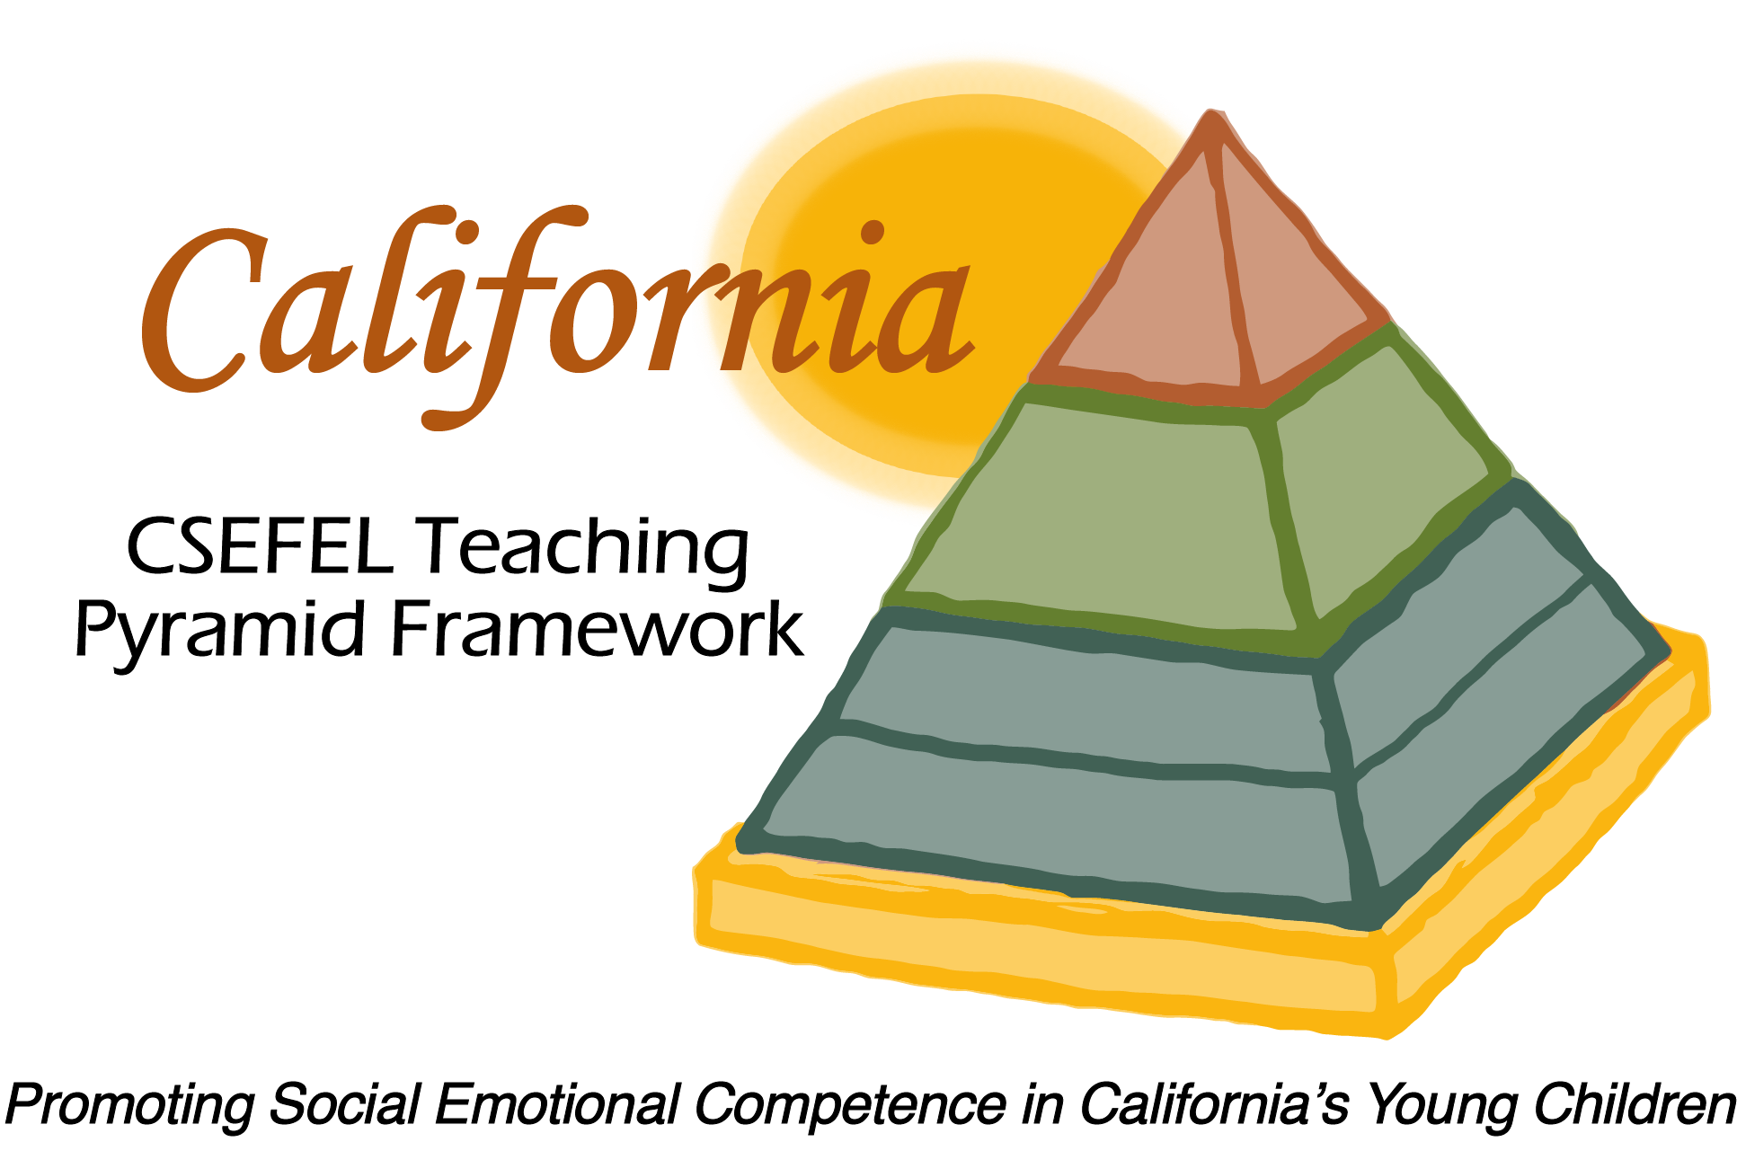

Verification of Hours Spent on a Professional Growth Activity

Title of the Activity:

CA CSEFEL Teaching Pyramid:

2016-17 Modules Update

Description of the Activity:

This WebEx training covered basic information regarding authorization parameters for CA CSEFEL Teaching Pyramid authorized trainers and coaches. It also introduced people to the ongoing support for authorized trainers and coaches during the 2016-2017 year.

Dates of Activity:
August 31, 2016

Number of Training Hours:
30 Minutes

Session Sponsor:

California Collaborative on the Social & Emotional Foundations For Early Learning
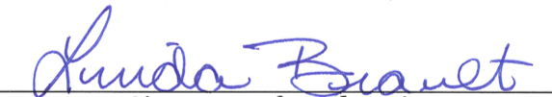
Project Director:
Linda Brault
Participant:

