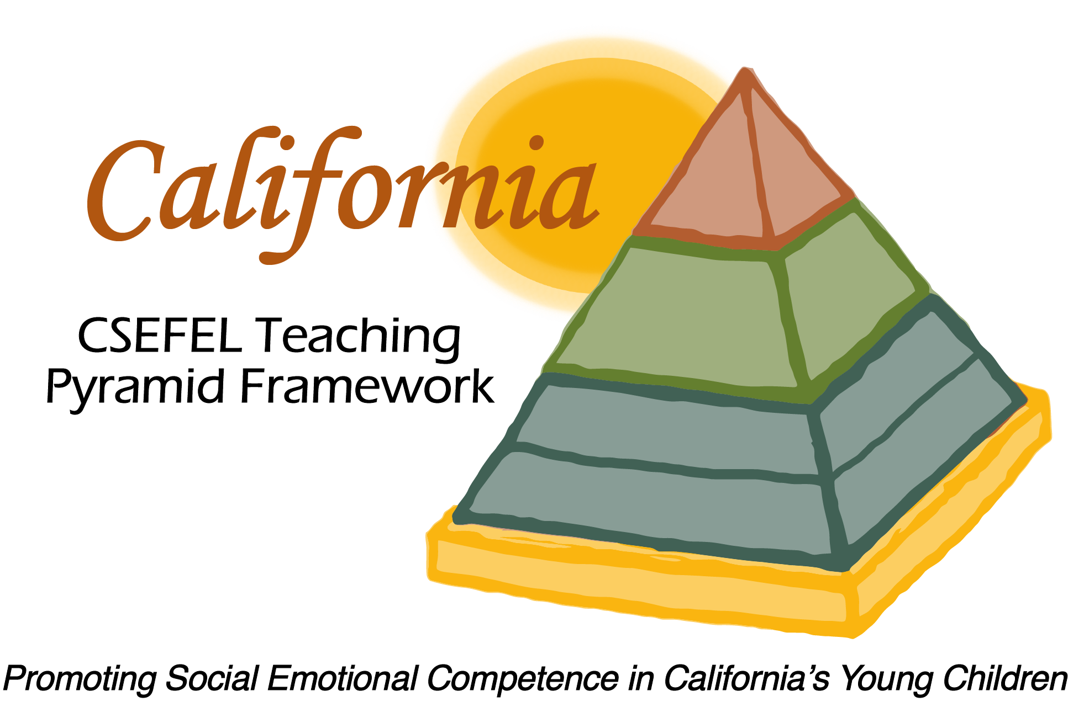

Verification of Hours Spent on a Professional Growth Activity

Title of the Activity:

The Teaching Pyramid Partner Sites Webinar Series:

Direct Teaching of Social Skills

Description of the Activity:

This webinar was conducted by the WestEd Partner Site Team of the WestEd Center for Child & Family Studies. This webinar focused on strategies for teaching friendship and social skills as a means of supporting healthy social-emotional development.

Dates of Activity:
March 10, 2015

Number of Training Hours:
1 Hour

Session Sponsor:

California Collaborative on the Social & Emotional Foundations For Early Learning
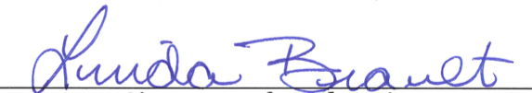
Project Director:
Linda Brault
Participant:

