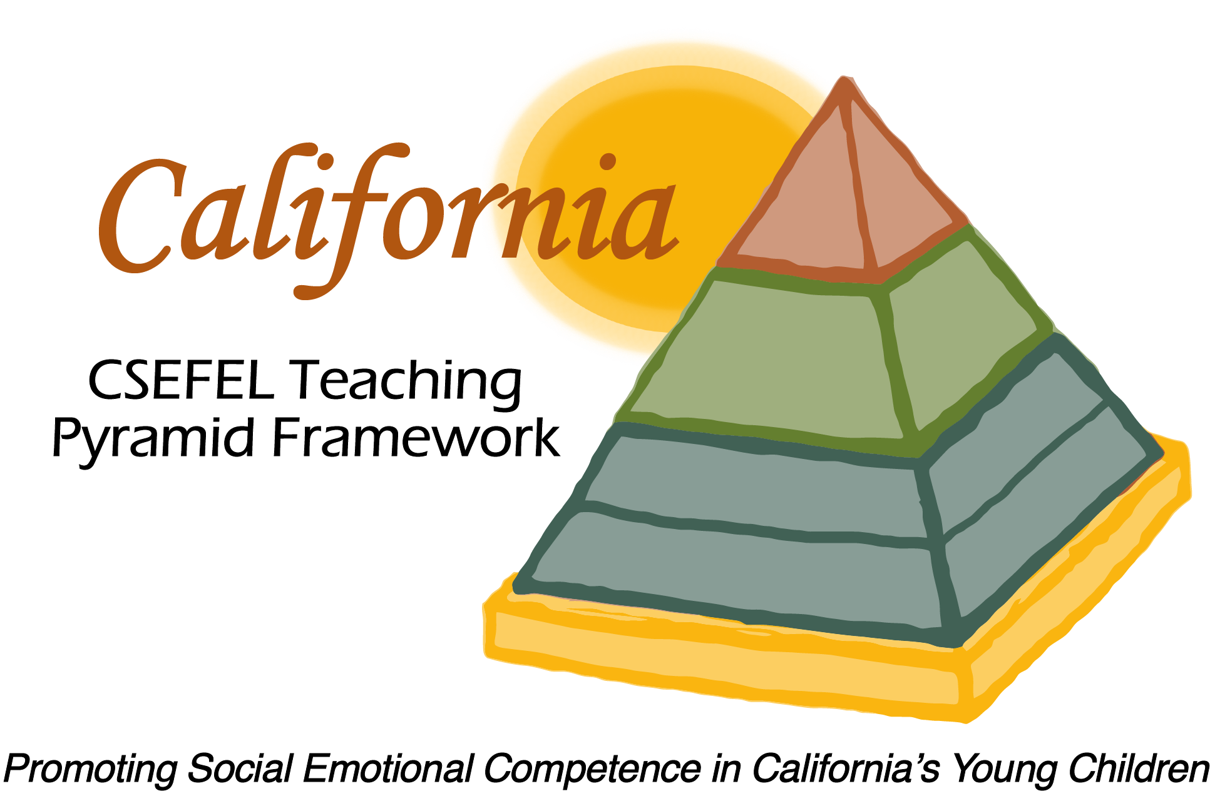

Verification of Hours Spent on a Professional Growth Activity

Title of the Activity:

The Teaching Pyramid:

Reflective Training Conversation

Description of the Activity:

Technical Assistance Conference Call with Open Conversation and Reflective Format facilitated by Julie Kurtz, LMFT

Dates of Activity:
February 10, 2016

Number of Training Hours:
1 Hour

Session Sponsor:

California Collaborative on the Social & Emotional Foundations For Early Learning
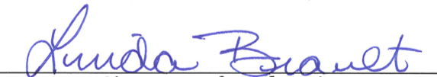
Project Director:
Linda Brault
Participant:

