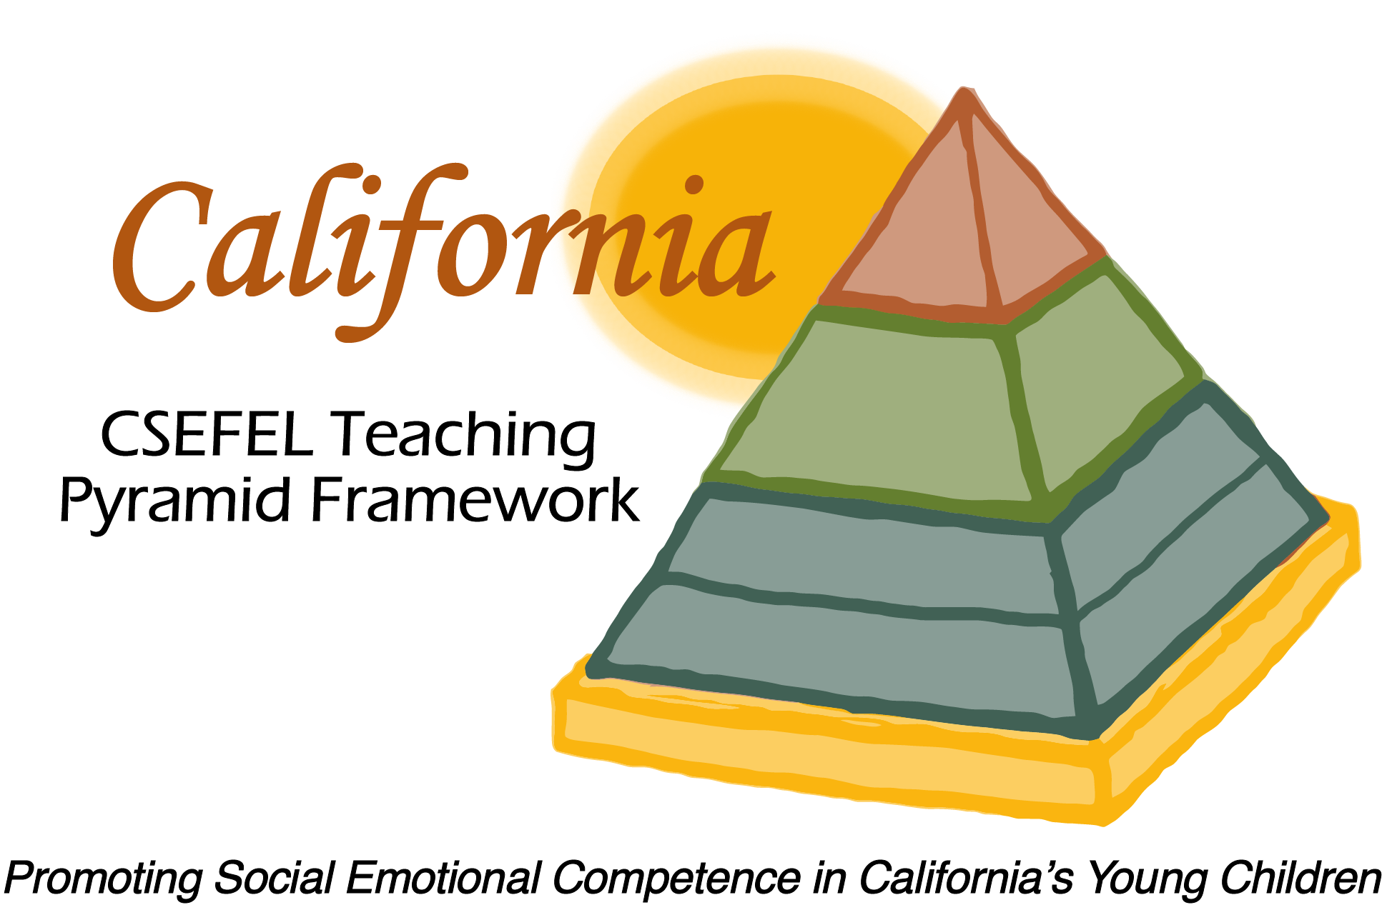

Verification of Hours Spent on a Professional Growth Activity

Title of the Activity:

Authorized Coaches for CA CSEFEL Teaching Pyramid:

Using Positive Descriptive Acknowledgement to Promote Social Competence and Reduce Challenging Behavior

Description of the Activity:

This webinar was conducted by the WestEd Partner Site Team of the WestEd Center for Child & Family Studies. This webinar focused on competencies of authorized coaches for the CA CSEFEL Teaching Pyramid.

Dates of Activity:
January 11, 2017

Number of Training Hours:

1 Hour

Session Sponsor:

California Collaborative on the Social & Emotional Foundations For Early Learning
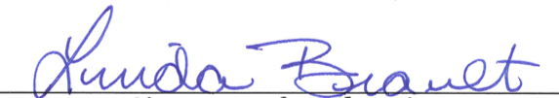
Project Director:
Linda Brault
Participant:

