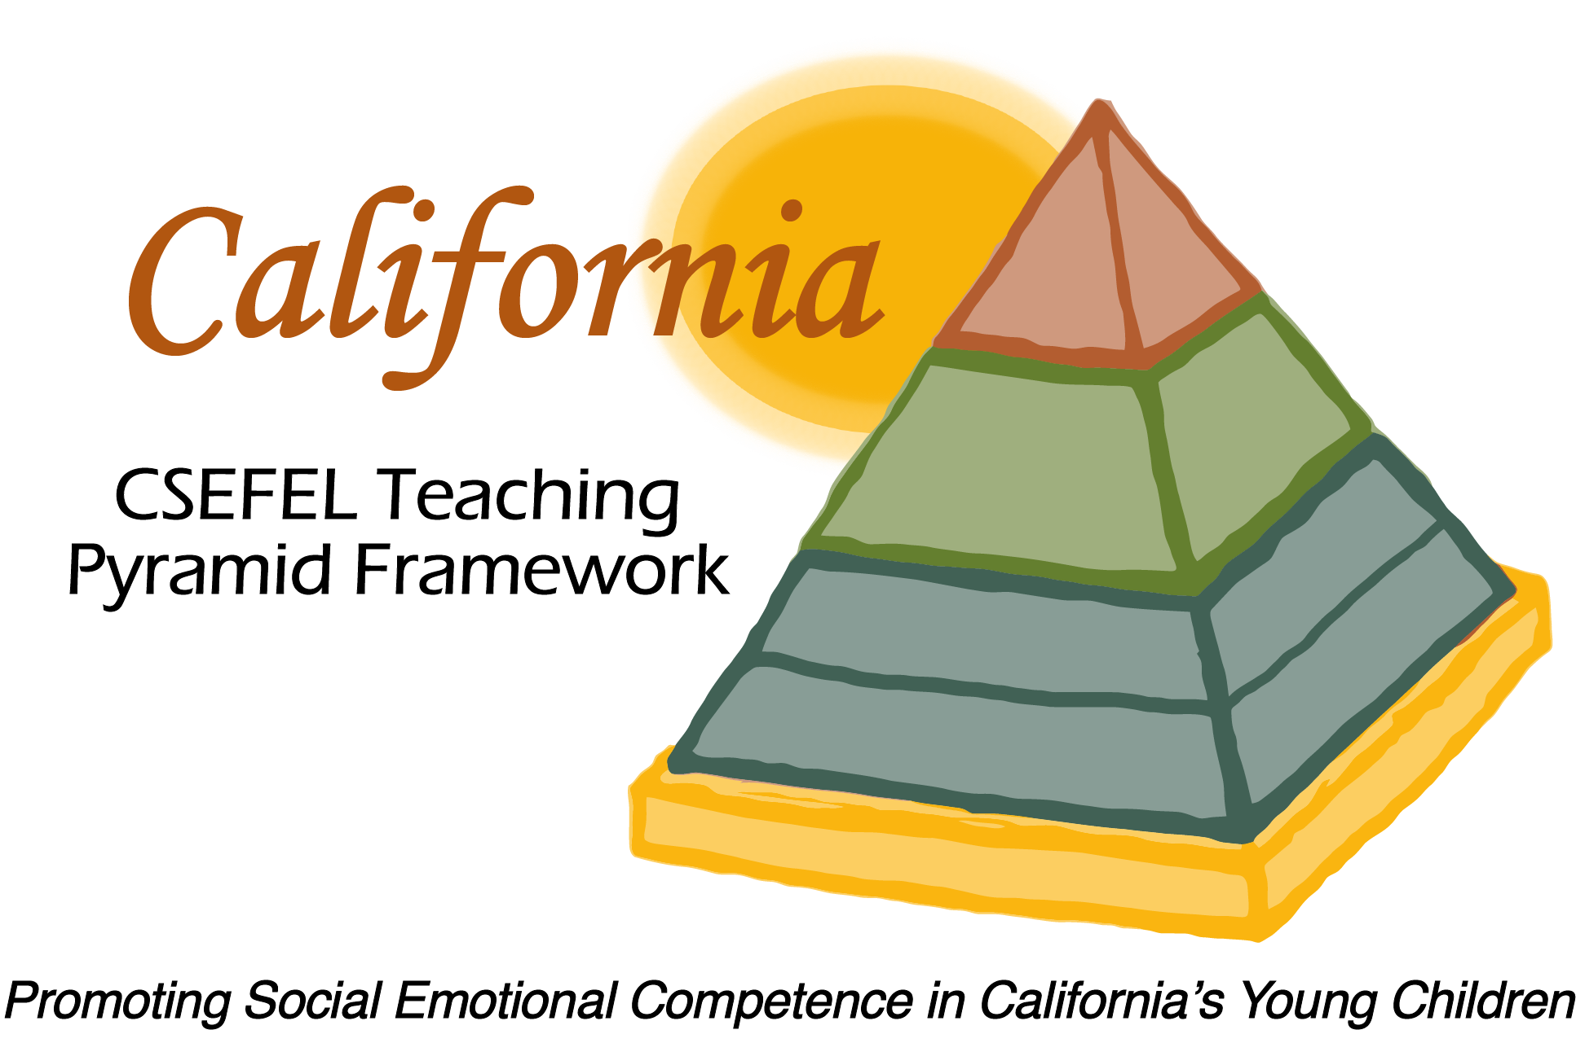

Verification of Hours Spent on a Professional Growth Activity

Title of the Activity:

Adult Learning Styles

Description of the Activity:

This webinar was conducted by the WestEd Partner Site Team of the WestEd Center for Child & Family Studies. This webinar focused on Adult Learning Styles.

Dates of Activity:
April 19, 2017

Number of Training Hours:

1 Hour

Session Sponsor:

California Collaborative on the Social & Emotional Foundations For Early Learning
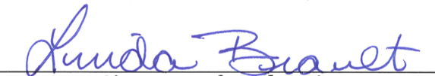
Project Director:
Linda Brault
Participant:

