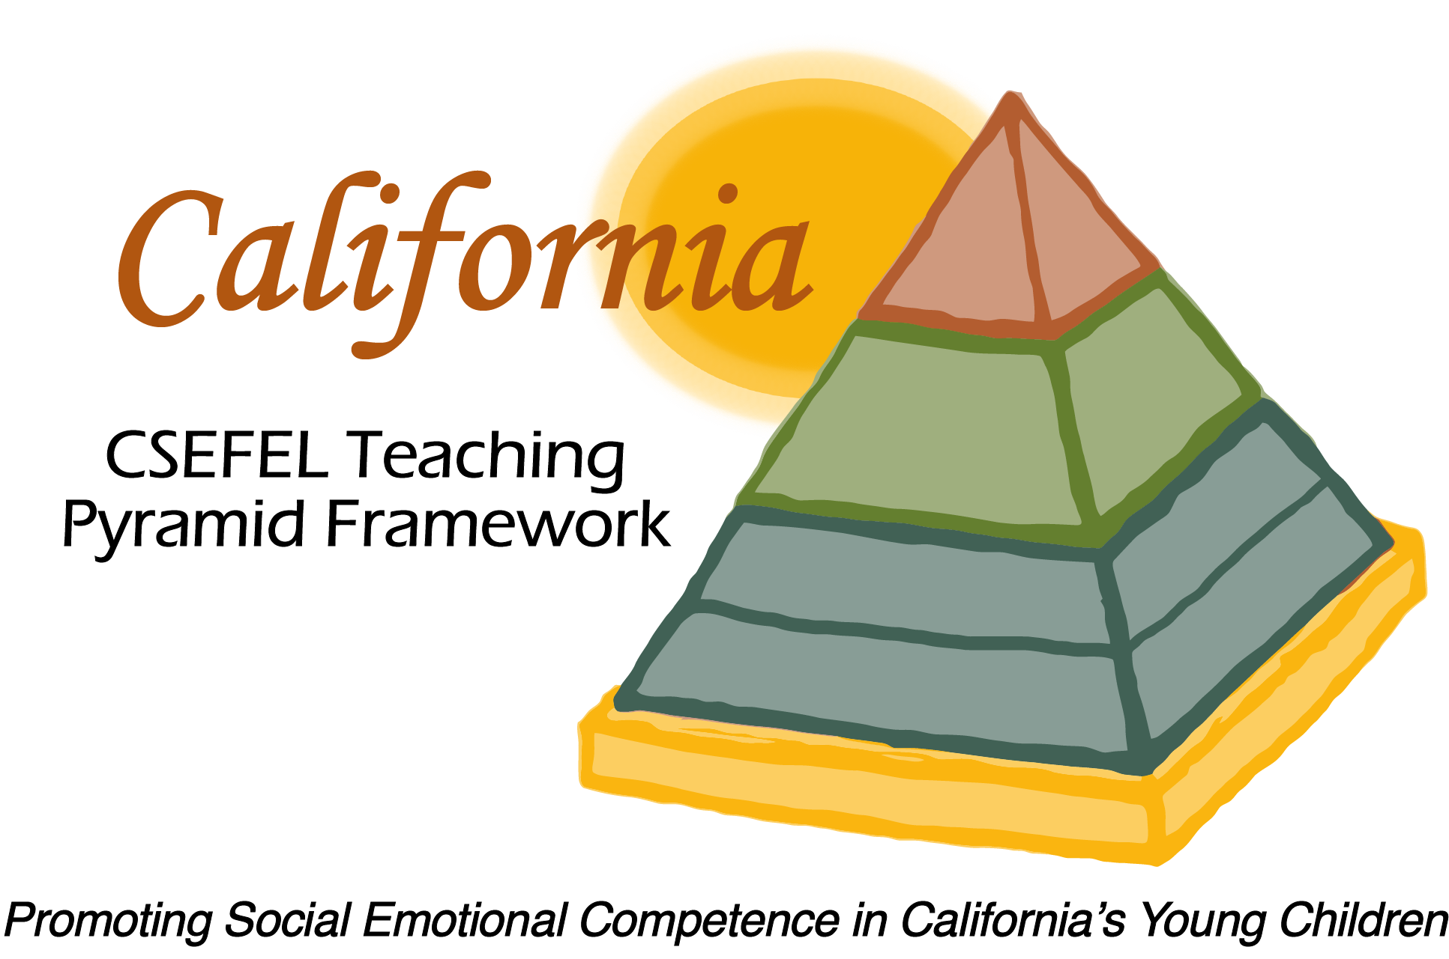

**Verification of Hours Spent on a Professional Growth Activity**

Title of the Activity:

|  |
| --- |
| **The Teaching Pyramid:** **Updates to the 2017-18 Preschool Modules** |

Description of the Activity:

This WebEx training covered 2017-2018 updates to Modules 1a, 1b, 2, 3a and 3b of the CA CSEFEL Teaching Pyramid for Preschool.

Dates of Activity:

August 30, 2017

Number of Training Hours:

One Hour

Session Sponsor:

|  |  |
| --- | --- |
| California Collaborative on the Social & Emotional Foundations For Early Learning | |
| Picture 5Project Director: | |
| **Linda Brault** |  |
|  |  |

Participant: