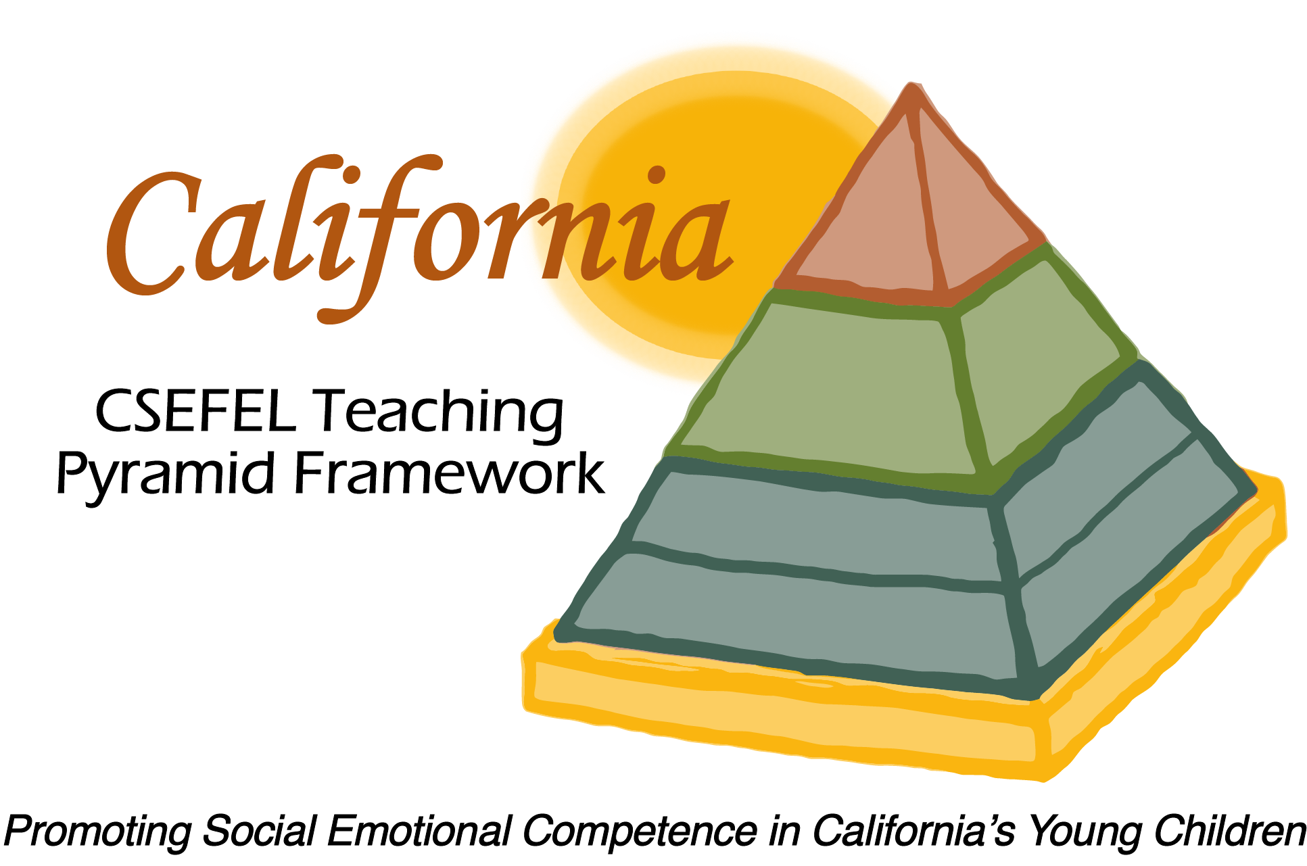

**Verification of Hours Spent on a Professional Growth Activity**

Title of the Activity:

|  |
| --- |
| **The Teaching Pyramid: Orientation for Newly Authorized****Trainers and Coaches** |

Description of the Activity:

This WebEx training covered basic information regarding authorization parameters for CA CSEFEL Teaching Pyramid authorized trainers and coaches and ongoing support for authorized trainers and coaches during the 2017-2018 year.

Date of Activity:

August 30, 2017

Number of Training Hours:

30 Minutes

Session Sponsor:

|  |  |
| --- | --- |
| California Collaborative on the Social & Emotional Foundations For Early Learning | |
| Picture 5Project Director: | |
| **Linda Brault** |  |
|  |  |

Participant: